MASTER OF COMPUTER SCIENCE IN ENGINEERING IN COMPUTER SCIENCE

HUMAN COMPUTER INTERACTION

A.Y. 2020/2021

**UNINOTE**

Authors:

Bovi Francesco 1803762

Davidde Francesca 1792368  
Ferrazzi Valentina 1756819

**Contents**

1. **Introduction** 
   1. The problem

1.2 The idea

1. **Requirement Analysis**

2.1 Competitor Analysis

2.2 User Analysis

2.2.1 User Profile

2.2.2 Persona and Scenario 1

2.2.3 Persona and Scenario 2

2.2.4 Persona and Scenario 3

2.3 Questionnaire Analysis

2.3.1 Conclusions

1. **Task Analysis**
   1. Select courses to join
   2. Manage course’s notification
   3. Take-Share Notes
   4. Find-Rank Notes
   5. Add course information
2. **Prototype 0**
3. **Expert based evaluation**

5.1 Cognitive walkthrough

5.2 Heuristic evaluation

1. **Prototype 1**
2. **Prototype 2**
3. **User based evaluation** 
   1. Think Aloud
      1. Task 1: View a course’s details
      2. Task 2: Know the lesson’s schedule
   2. Cooperative Evaluation
   3. Controlled Experiment
      1. Problem
      2. Sampled Users
      3. Variables
      4. Hypothesis
      5. Experiment Details
      6. ANOVA Results
4. **Prototype 3**
   1. Final system
5. **Conclusion**

10.1 Future works

1. **References**
2. **Introduction**
   1. **The problem**

Sometimes, to have a good university organization seems to be hard. It becomes more difficult especially when students are really busy and there are a lot of courses to be attended. During a university day or a university year there are a lot of important information to keep in mind: exam dates, homework deadlines, lessons schedule, how the course will go on, how the professor will keep in touch with his students and so on. Professors do not all use the same platform (some use Piazza, others Classroom and others e-learning), and here another problem comes out: students often do not remember if a certain teacher uses one platform rather than another one. To solve the problem, some students save the web page as a browser favorite page while some other take notes on their notebook. If we focus on lesson schedule, the same problem appears: some professors provide the lessons schedule by their web page while some others directly tell the students, some other course’s schedules are published by university we page, etc…

Other difficulties occur when students look for good notes to study. Almost all students have lost at least one lesson. How to get that lesson’s notes? If we have a trusted friend the problem is solved but what if we do not have one? We are used to ask somebody to please send us the notes, read it and then decide if it was a good notes or not. If it wasn’t’ we have to look for another one. Well, university’s organization problems are a lot and our application will try to solve all of them.

* 1. **The idea**

UNINOTE aims to help university students to have a good organization of courses and information related to them (such as info about the exam methodology, homework, ...). UNINOTE offers students a board in which it can be seen the list of courses with the respective links that refer to the platform chosen by the professor (e.g.: Piazza, Classroom, ...) and the platform chosen by him for distance learning (e.g.: Google Meet, Zoom, ...).

The application will be mainly used by students. Professors have only to upload all the information about courses (thanks to questionaries we will see if it is feasible or not. Otherwise, this task could be done by an admin), and for the other features it will be used by students in order to have a global and unique platform to check anything they need.

In order to provide a clear organization: there could be a weekly timetable in which courses are represented and also a map which worries about where the lesson is going to take place. There could be also the possibility of receiving a notification few minutes before a lesson starts.



Figure 1. UNINOTE logo

In addition, the app creates the "student diary", customized according to the courses that the student attends. This “student diary” contains folders (named with the respective course name) in which the student can save his notes (so to have them always available wherever he is).

Indeed, UNINOTE gives students the opportunity to take notes directly on the app by providing a "notepad". Then, notes can be saved in the private course folder or can be shared with other students.

Finally, there is the possibility of making reviews (expressed with a number of stars ranging from 1 to 5) to an answer given by another colleague so that you can share with others how useful it was.

1. **Requirements Analysis**

Requirements Analysis is the first step to be done during a software development process which has to be user centered. One of the most important phases is to understand which are our target users, which are their problems, if somebody has already tried to solve these problems and how it was done. In this way we can have a complete vision of the space where we are going to work. This information is obtained thanks to Competitors Analysis, Questionnaire Analysis and User Analysis.

* 1. **Competitors Analysis**

Let’s first check if somebody has already developed an application which helps university organization. Analyzing the competitors’ strengths and weaknesses we can collect details. Thanks to competitors’ weaknesses we can know what our application has to offer.

There are three main competitors to our application:

* **Uniwhere:** An application that allows students to keep track of their votes, progress, write note and read courses reviews;
* **Notion:** An application that allows to create workspace, take notes and share material;
* **Infostud:** An application for Sapienza’s students, that allows them to check their university career and offers a courses’ timetable;

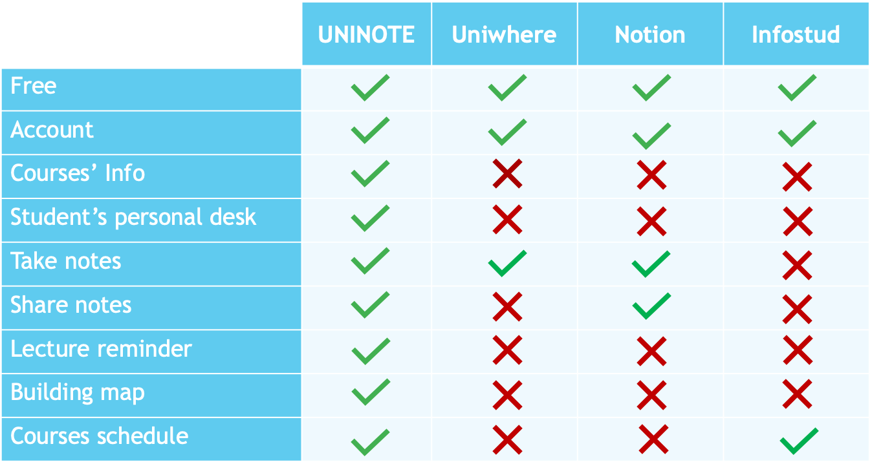

Figure 2. Competitors Table

The above table describes the various features of each application including UNINOTE. The analysis suggests us to offer all the services the other applications do not offer. In this way students can find useful our proposal.

* 1. **User Analysis**

Since we are talking about user centered design, the most important element which has to be analyzed is the user. Once the idea is ready, we cloud imagine how the system should be but we have to understand which are the constraints our system may relax and which are the constraint is has to satisfy. This is done considering our users.

We need to know:

1. Who our users are?
2. Why they should use our system?
3. Where? Under which conditions do they need to use the system?

We need to know as much characteristics as possible in order to provide him the most suitable system.

* + 1. **User profile**

To understand how the application features should be developed, we have to identify which user target the system could refer to.

Since UNINOTE is a university application the generic target user might be a student. University student’s age is almost in the 18-35 range and nowadays 18-35 years old people have good familiarity with technology. So, we can suppose, our generic target user to be able to interact with both mobile and desktop applications.

Below we summarized the relevant user characteristics:

* Age: 18-35 (average 27)
* Gender: Any
* Profession: Student or working student
* Location: everywhere
* Technology: Familiarity with smartphone and desktop application
* Disabilities: No specific limitation
  + 1. **Persona and Scenario 1**

Once identified the generic target user we can go into more details and find out some examples of personas and scenarios. This additional step allows us to simulate and better understand what are several common situations in which our users could be. Thanks to these additional details we can figure out some features UNINOTE should provide. Scenarios suggest us what are the problems a common user could have and tells us about the possible solutions. It also helps us to know in which situations our system could be used and therefore what is the best interface it should have.

To obtain all what is described above, let’s define three personas and three scenarios. We decide to choose these examples in order to cover each user’s possibility.

The first persona we propose is the common and simplest user we can imagine: a valedictorian.

**Persona General Info**

* Name: Matteo
* Gender: Male
* Age: 24 years old
* Profession: student
* Location: Latina

**Persona description**

Matteo is one of the best students of the Physics master course and he lives with his parents and his brother. He is attending his senior year and he is going to graduate on the next summer.

He is a really curious guy and he is always looking for something new to learn. He loves exchanging ideas and opinions with other students in order to keep up with the times. He thinks he has a lot to learn from other students and they can learn a lot from him too.

Matteo really loves to study and he spends a lot of time on it. He does not miss any lecture and he pays attention on everything professor says. In order to be fast, he is used to take notes on PC. It also helps him to manage his material. Indeed, he creates a folder for each course he is attending and he saves the corresponding notes in it.

Matteo is a sporty person: during his free time, he is used to go jogging with his brother, while on Monday and on Friday he plays tennis. Sport helps him to relieve stress. He thought to give up the Tennis Club because of studies. Then he realized: it’s just a matter of finding the right balance!

**Scenario**

It’s the last week of May. The second semester of the master in Physics has almost finished. Matteo is getting ready for the exam summer session.

He is a very careful and organized student and, for this reason, he has attended all the lectures and as he is used to do, he has put together all his notes in some PC folders. His desktop is full of them and there are also other private documents and private folders in it. So, he has some difficulties on checking up what he really needs.

Furthermore, next week exams will start and Matteo is studying a lot and he is doing also a lot of exercises in order to get good marks. He wants to compare his opinion with other colleagues and so he uses WhatsApp and Telegram's chats. Unfortunately, Matteo has to check if a course is associated to a WhatsApp chat or a Telegram one and he gets so annoyed wasting time!

The exam period is very important for him, therefore he has decided to stop playing tennis for a while! He gets a lot of deadlines to meet! He has to deliver final projects and he has also several meetings with the relator for questions about the degree thesis. To do not let those commitments drive him crazy, Matteo uses his calendar on mobile phone and he writes down the various appointments. Everything has to be perfectly organized!

* + 1. **Persona and Scenario 2**

The second persona we propose is a normal girl which in addition to be a student is also working. Thanks to this situation we can understand what problems occur when a user has not so much time.

**Persona General Info**

* Name: Federica
* Gender: Female
* Age: 23 years old
* Profession: worker and part-time student
* Location: Rome

**Persona description**

Federica is a part-time student; she lives with her parents and she is attending the master-degree in Engineering in Computer Science (Sapienza University) while she is working as Java Developer for a company.

She is really busy and she has no free-time at all. Federica really thanks her mother, who worries about everything her daughter needs. So, Federica has always her packed lunch ready! Her bedroom is always tidy, even though she doesn’t lift a finger!

Federica spends all her mornings at work and all her afternoons studying and doing university stuff. Her daily routine is really stressful: she wakes up very early, she gets ready and she goes to work. At 1 p.m she gets off and, if there are afternoon lectures on her schedule, then she attends them. Otherwise, Federica comes back home and she studies something about the morning lectures she has lost.

She is a really good student and since she cares a lot about her university career, she always tries to do her best.

Usually, she is a very neat person, she really likes to have all university notes and material well-ordered. Unfortunately, she is always in a hurry and therefore she has not so much time to organize everything she needs.

**Scenario**

It’s one of the first days of March and the second semester of the first year of Engineering in Computer Science has just started.

Federica was really excited about this new beginning, but unluckily she could not attend all the classes because she works in the morning. The first week is usually one of the most important weeks of the semester. Professors introduce their courses and they provide students important information and instructions about the organization of the course.These basic information are related to the platform used to attend lectures, the website in which students can find all the needed materials, what kind of final exam there will be and additional information about projects and homework.

Since Federica missed some first lectures, she has to check on Sapienza web site if what she needs is there. Sapienza website is not always clear, so she has to spend a lot of time on searching on professor private website or course’s pages. At the end, she has maybe collected all the information. Information is a lot: how much time she will take to memorize them?

Federica already knows her biggest problem is related to the room in which each class will take place. She has always had trouble with them. One imagines her, being in hurry, looking for the geolocation of a room on Google Maps.

* + 1. **Persona and Scenario 3**

The last persona we present is a particular one. She is a woman; she is a mother; she a worker and she lives far away from the university. Thanks to her situation we can understand something more about our users.

**Persona General Info**

* Name: Sara
* Gender: Female
* Age: 30 years old
* Profession: mother, worker and part-time student
* Location: Tivoli

**Persona description**

Sara is a 30 years old woman. She lives in Tivoli with her family which consists of her husband Giacomo, her 8 years old girl Ludovica and her lovely dog Poppy. She works as physiotherapist in Rome but she is not satisfied about her job: she would like to be a kindergarten teacher. So, the last year she has decided to start university again. She enrolled in Primary Education Science course at Sapienza University.

Whole Sara’s life is about her daughter and her family. So, she does not devote a lot of time to university stuff. She studies just when she has free time (usually at night) and she does not expect to pass too many exams during the year. After all, she is a mother, a wife, a worker and at the end she is also a student.

Sara is a cluttered person and it does not help her to manage all her daily tasks. She is that kind of person that usually forgets where she rests her phone just two minutes after she rested it! On the contrary, she is flawless about her daughter. Sara always cares about Ludovica’s life. So, Ludovica is always in time at school, she has never missed a dance lecture and she has always got good marks at school.

During the weekend, Sara loves to spend time with her family. She is used to spend summer afternoons in the garden. She lets Poppy and Ludovica play on the grass while Giacomo cooks some pancakes! A perfect family scene!

**Scenario**

It’s 15th December morning. Christmas holidays are going to start in a few days. Sara is thinking about the Christmas’ Eve menu: this year it will take place at her house and it must be perfect! December has always been a very busy period. Ludovica is actually a really challenging girl. She is getting ready for the Christmas pageant and also for the year-end essay (dance show). So, she has many lines to learn, many extra schools work to do, many ballet routines to go over. Ludovica really needs mum’s help.

Additionally, Sara should start to organize her university stuff in order to attend at least one exam on January.

After work, she drives Ludovica to the Dance School. When Sara is at home, she decides to register for the Children’s Literature exam. Then she searches the course’s summary and the slides to study. Since she has some free time, she starts to read them. The material is really bad made and it is not enough to pass the exam! There is not even a book to refer to! Sara has no colleagues at university that can suggest her how to get ready for the exam. She’d really like to consult some well-written notes! But where can she find them? There are no good notes on the web!

It’s almost time to pick up Ludovica. Giacomo is coming back from work and she has to make dinner.

Sara lights the Christmas tree and she sighs: she will look for a solution!

* 1. **Questionnaire Analysis**

The requirements gathering can be divided into two phases: the first one is related to understand the situation as is without our system, the second one considers what happen when we introduce our system. So, the most important thing is to understand which is the current situation. Personas and Scenarios helped us about it, but we need some more information. To reach as many people as possible we decide to use questionnaire. It was developed by using Google Form tool thar allows to create simple surveys and analyze the answers using pic charts. The questionnaire was pre-tested which a small set of users just to know if it was well structured. Then it was distributed by sharing the link via private message and is has been completed by 198 students.

**First Part**

The first questions were used to have an idea about the student who was answering the questionnaires.

* What is your gender? (Figure 2)
* How old are you? (Figure 3)
* How many years have you been attending university? (Figure 4)
* Do you live in the same site of your university? (Figure 5)
* If you are a university student, which university do you belong to? (La Sapienza, Roma Tre, Tor Vergata ,etc) (Figure 6)
* Which category of student do you belong to? Remember: a part-time student is a student how has also a job. (Figure 7)

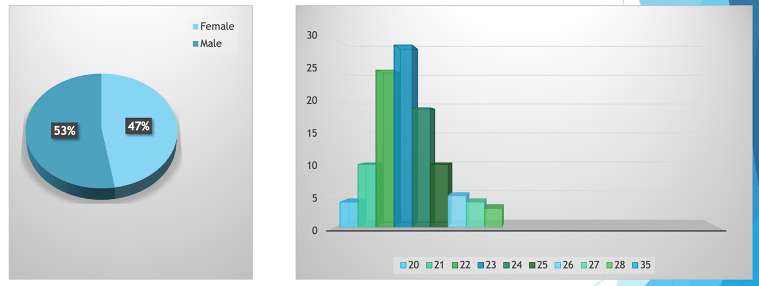

*Figure 3. Age answers*

*Figure 2. Gender answers*

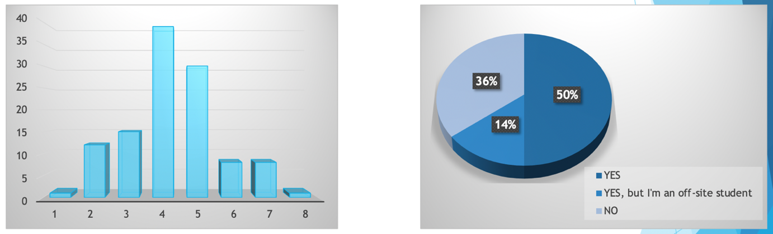

*Figure 5. University distance answers*

*Figure 4. University years answers*

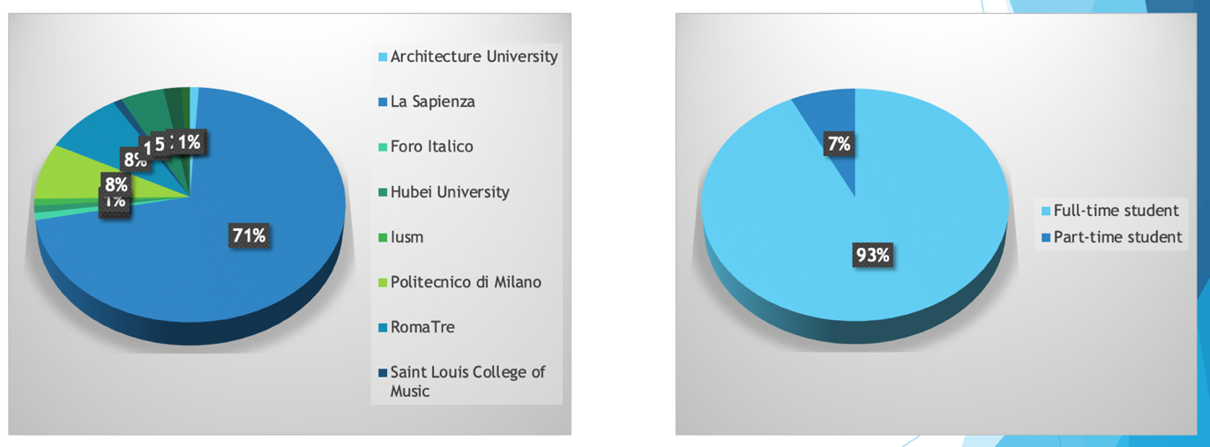

*Figure 7. Student type answers*

*Figure 6. University answers*

Looking at the graphs, we can assert: our users are almost all full-time students, most of them is attending the fourth-fifth university years, most of them are 22-23-24 years old. Some of them lives in the same city where the university is while some other live far away from the university so we suppose they spend some time by driving or on some public transports.

**Second Part**

The second part of our questionnaire is intent to investigate about how students find out information they need.

* Where can you find indications about the platform (Classroom, Piazza, specific web site) used by the professor to contact his student? You can choose more than one option. (Figure 8)
* Where can you get information related to your class' schedule? You can choose more than one option. (Figure 9)
* During this pandemic period, lessons are mostly online. How do you get the link professor uses to have lessons? You can choose more than one option. (Figure 10)
* Where do you find the material (slides, books, recordings of the lessons, etc) that is useful to get ready for the exam? You can choose more than one option. (Figure 11)

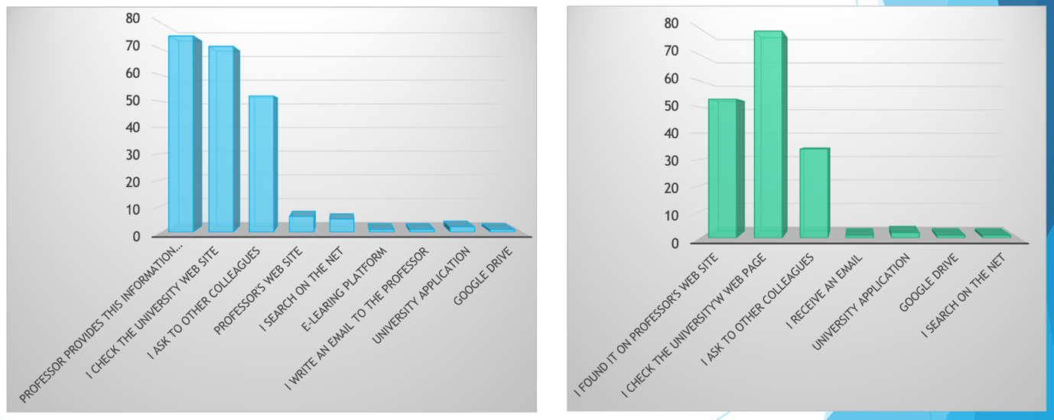

*Figure 8. Platform indications answers*

*Figure 9. Class’ schedule info answers*

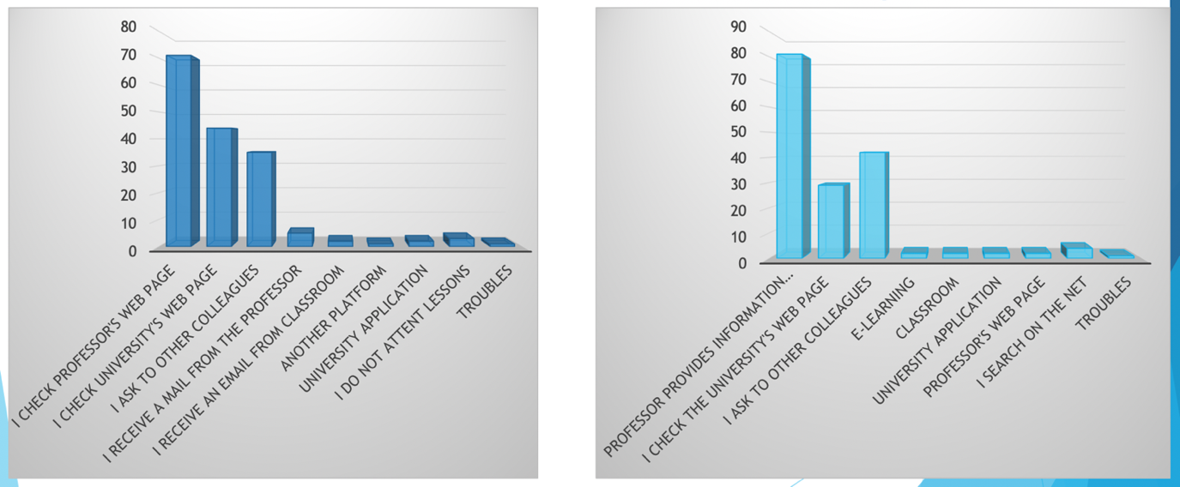

*Figure 11. Retrive material answers*

*Figure 10. Online lessons info answers*

Answers’ distributions tell us there is not a unique way to get all the university information a student needs. Indications about the platform used by the professor to contact his student seems to be provided by the professors himself and by the university, while some other information comes from asking to other colleagues. Looking at the right parts of the graphs, part of students seems to be confused and looks for university information on the Net. Another important element we would like to focus on is the answer ‘University application’. It suggests us an application that collects all what a student needs, is already be implemented.

**Tirth part**

Thanks to this part we want to know if our application will be useful. The answerers were positive, our idea could really help the students organization!

Some students are also available to add information they have in the application in order to share them with other students. This is really important since we were thinking about some kind of student administrators.

* Let’s suppose there is an application that provides all this information on a unique dashboard. Could it help you with the organization? (Figura 12)
* Would you be available to collect and insert the information (platforms professors mainly use, lessons’ links, class’ schedule, ecc) in the application? (Figura 13)

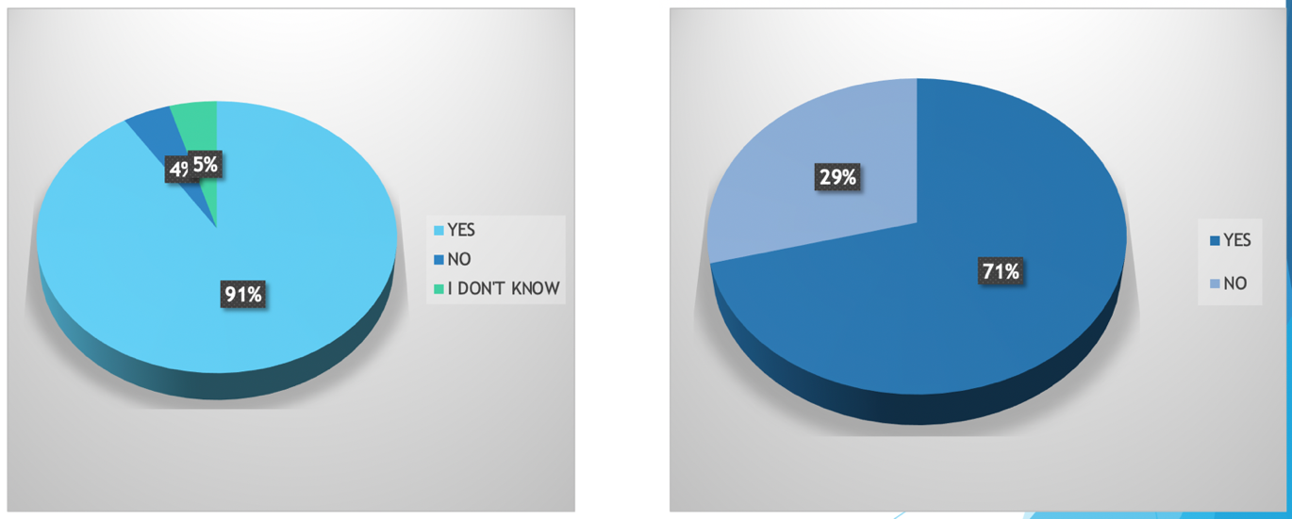

*Figure 12. System utility*

*Figure 13. Possibile admin*

**Fourth part**

Through the questions in this part, we analyzed how often students personally take notes during the lessons and which tool they use, this is important because it confirmed the needs of a specific section where to take notes in our application (only Desktop version because mobile one would be uncomfortable) in order to have them tidy and ready to be shared with the other users using the application.

* How often do you take notes of the retrieved information (lectures’ links, courses’ schedule, platform used by professor, etc..) ? (Figure 14)
* Do you save them using any tools, which tools do you mainly use? (e.g.: digital tool like Excel, you just write down them on a paper, etc…) (Figure 15)

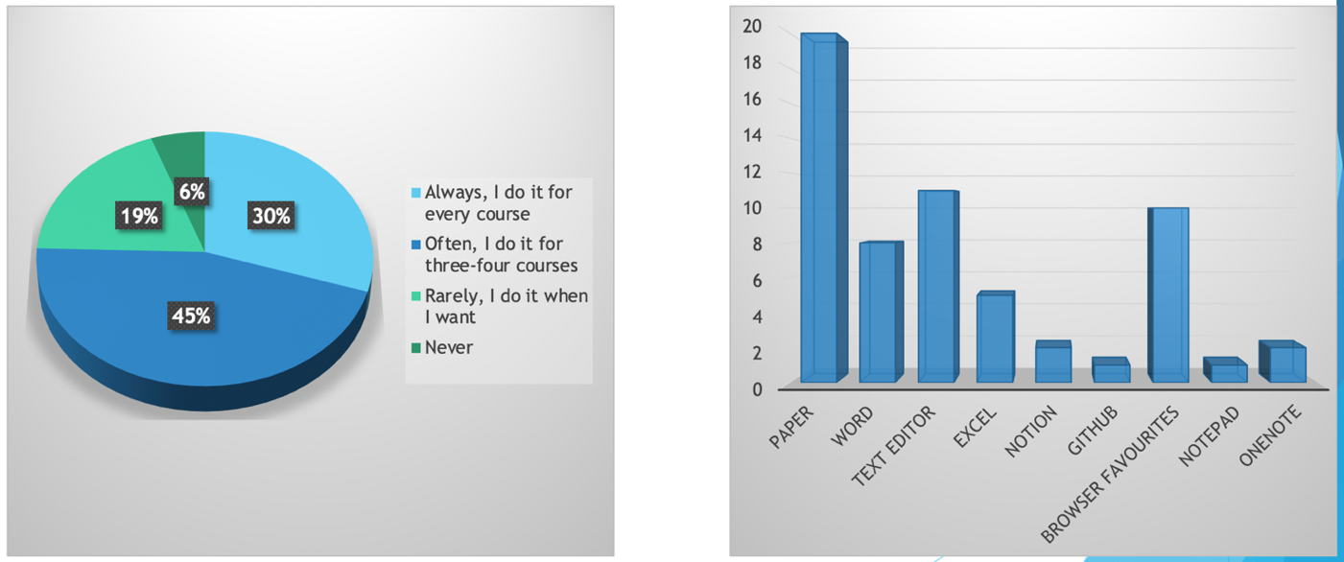

*Figure 15. Tools used to take notes*

*Figure 14. Notes taken percentage*

**Fifth part**

In this part we concentrate the analysis on how the students communicate one with the other, this is important to check if they are aware of the existing communicating channels and find which are the most used by the students. Since the results showed that nearly 1/3 of students were not aware of the existing social channel, this leads us to add this information on our application (link to Telegram or WhatsApp groups).

* Are you aware of the existence of social channels with used to communicate with your colleagues?(Figure 15)
* If you answered "Yes" to the previous question (otherwise skip this question): How did you find out?(Figure 16)

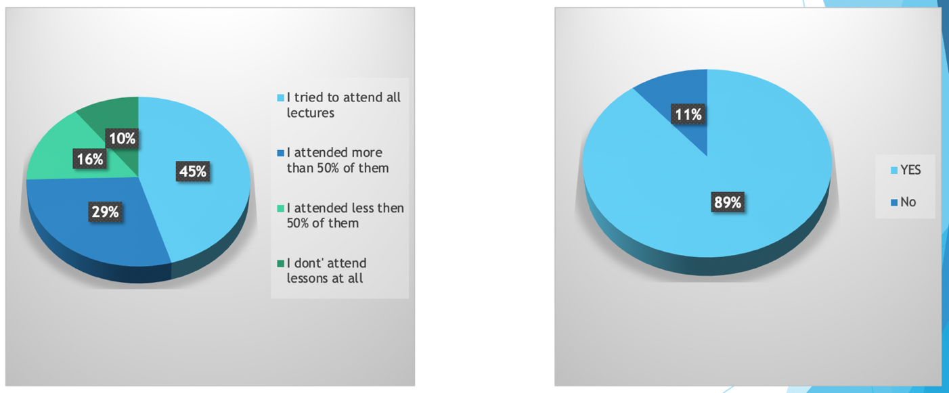

*Figure 19. Difficulty in reaching rooms*

*Figure 18. Lectures attended*

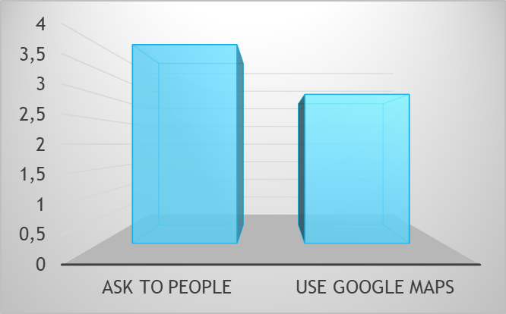

*Figure 20. Tools used to solve the problem*

**Sixth part**

In this part we concentrate on the notes, we can divide in two subparts:

6.a : We wanted to investigate the most used tools for taking notes and why students choose them, in order to understand which features is important for them;

6.b : This subpart analyzes the importance of sharing notes between the students, if they have already a tool for it and how much students use others notes for preparing an exam.

This is probably the most important part of the questionnaire and the results were very useful, especially because convinced us about the possibility of sharing notes directly in our application and rating them in order to help students in reading good notes.

* How do you take notes? You can choose more than one option. (Figure 21)
* If you selected "Copybook" or "both copybook and PC/tablet", please answer the following question: Why do you take notes on your copybook rather than on PC/tablet.. ? (Figure 22)
* If you selected "PC/tablet" or "both copybook and PC/tablet", please answer the following question: Which kind of tool do you use to take notes (e.g.: Word, Note, ..)? (Figure 23)
* How often do you share your notes? (Figure 24)
* If you are used to share your notes: how do you share them (e.g.: Google Drive, specific application, simply using WhatsApp, etc..)? (Figure 25)
* If you selected "PC/tablet" or "both copybook and PC/tablet", please answer the following question: How do you organize your notes?You can choose more than one option. (Figure 25)
* How often do you consult other colleagues’ notes? (Figure 26)
* Do you have any difficulties in finding good notes taken by other students? (Figure 27)

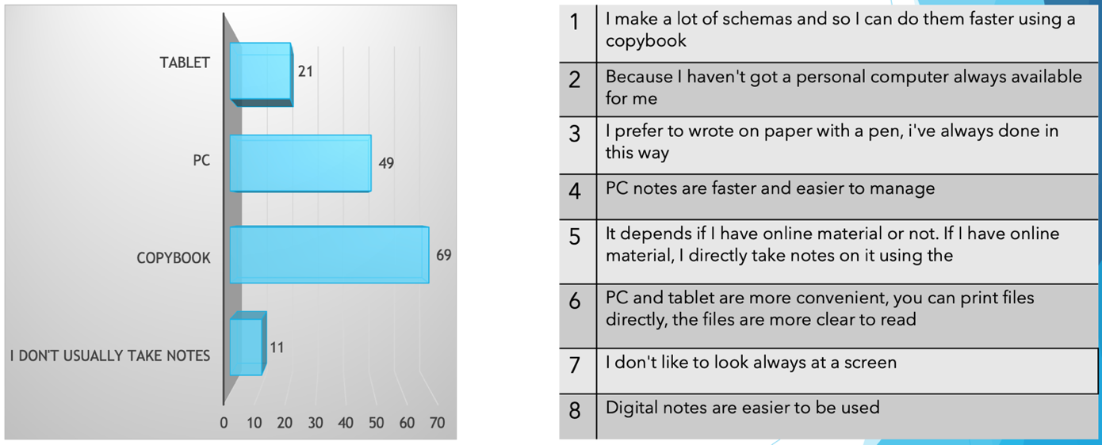

*Figure 22. Reasons for choosing an instrument*

*Figure 21. Instruments for taking notes*

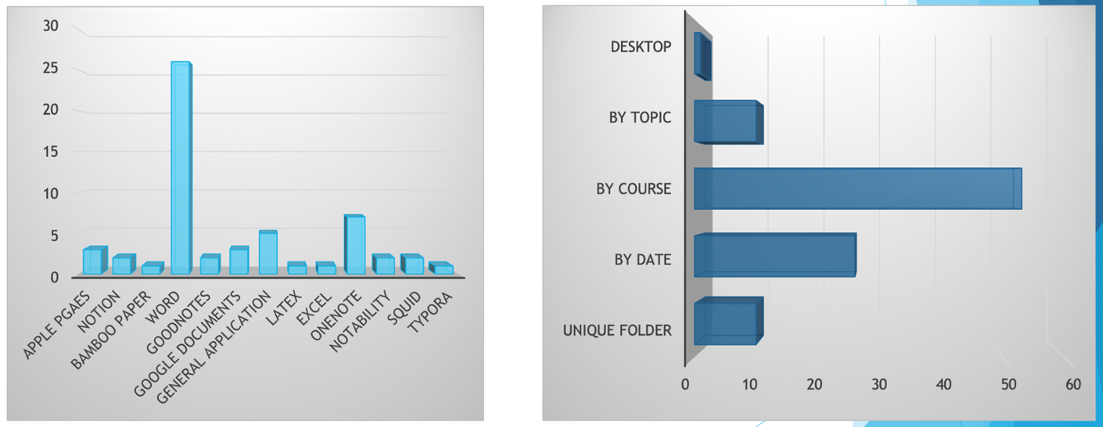

*Figure 24. Ways of organizing notes*

*Figure 23. Tools used to take notes*

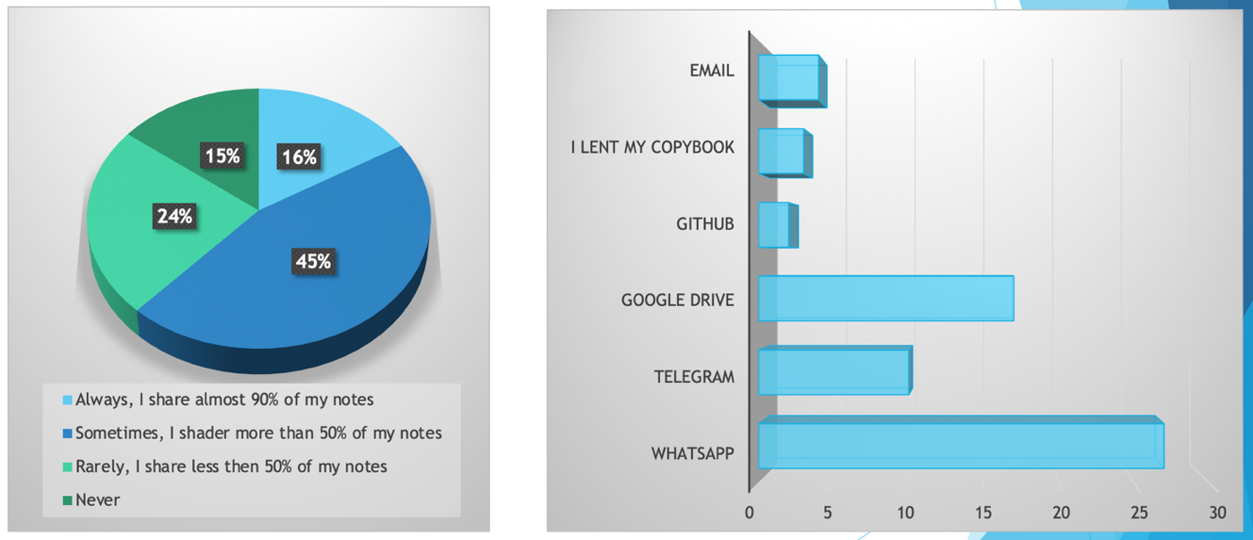

*Figure 25. Share notes percentage*

*Figure 26. Ways to share notes*

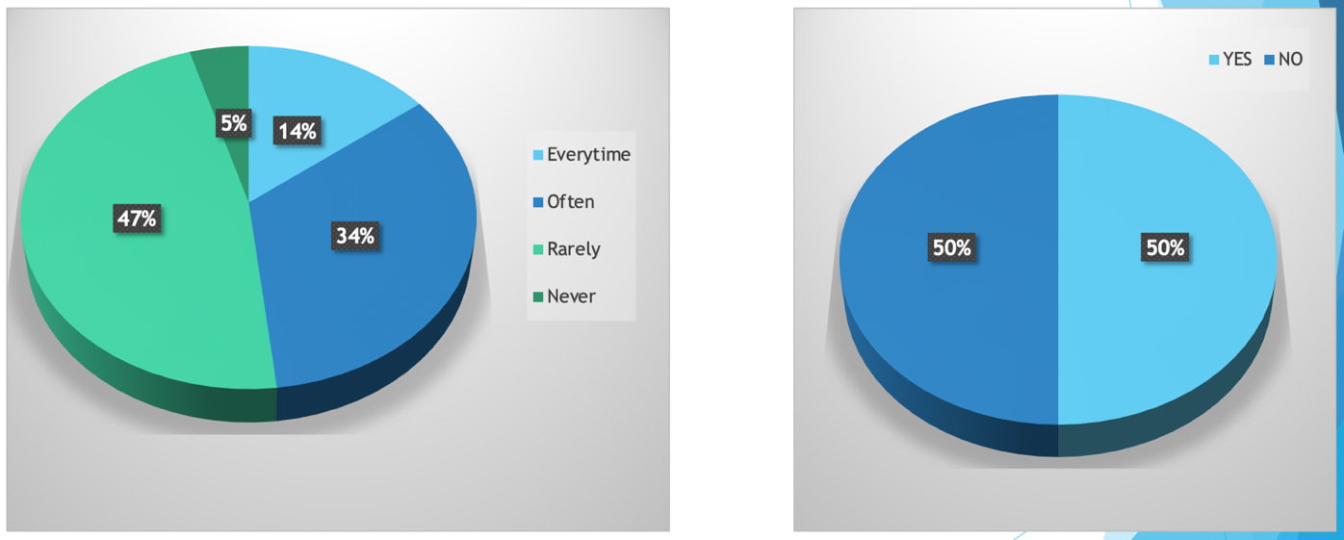

*Figure 27. Times students use others notes*

*Figure 28. Ease in finding good notes*

**Seventh part**

The seventh and last part of the questionnaire concentrates more on the mnemonic information that a user should remember during the courses like the timetable or the exam/homework deadlines, so we checked the usefulness of having all these information on a unique platform, avoiding to the student the effort of remembering by heart.

* How do you remember the deadline of homework/meeting/..? You can choose more than one option. (Figure 29)
* An application that notifies about an impending deadline or about the beginning of lessons could be useful? (Figure 30)
* How often do you remember the calendar of lectures (lectures schedule) by heart? (Figure 31)

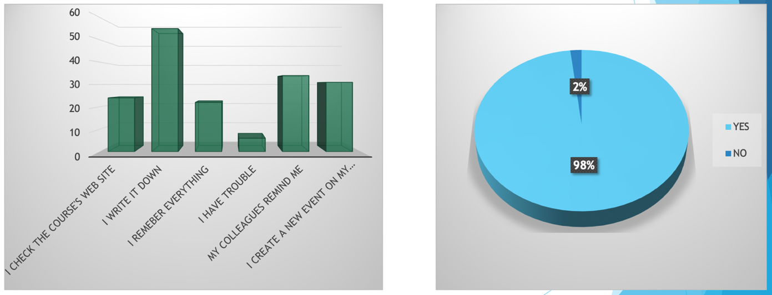

*Figure 30. Usefulness of notification of deadlines*

*Figure 29. Ways for remember deadlines*

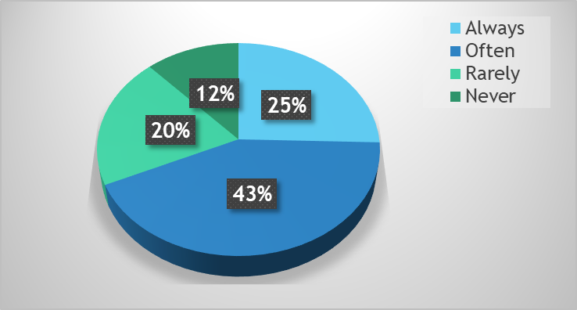

*Figure 31. Remember timetable by heart*

* + 1. **Conclusions**

From the analysis of the data coming from the questionnaires, we can say that:

* Most of the answers come from students of “La Sapienza”;
* Most of the students involved in the questionnaire are full-time students (they do not work);
* The 91% of the students who answered the questionnaire need help to organize their ‘university life’;
* Most of the students involved in the questionnaire follow all the lessons (or at least try their best);
* Almost all the students involved in the questionnaire have problems finding classrooms;
* A good percentage of the students who answered the questionnaire take notes on the computer and share them with other colleagues;
* Most of the students who answered the questionnaire share their notes with other colleagues but there is no platform that prevails over the others.

1. **Task Analysis**

Once the requirements analysis has been completed, we have a clear idea about our users and about the context in which our system is going to be used. In this section we will focus on what the user will do in order to complete some tasks and how the task can be executed using our system. The first info is given thanks to the Hierarchical Task Analysis, while the second one is obtained by using the State Transition Network.

The main task we want to study are the following:

* A user joined a new course and what to add it to the list of the course he is attending;
* A user is attending a course and he want to be notified about the course’s deadlines;
* A user wants to take notes and then decide to share it with other colleagues;
* A user is looking for good notes and once he has found it, he wants to express his opinion;
  1. **Select courses to join**

The user looks for a new course to be added in order to:

1. Have its information in the homepage;
2. Have it included in the class schedule;
3. Access the shared course notes;
4. Write his personal notes in the course’ folder;

To search the course, he can use either the course name or the course code.



*Figure 32. Select course to join HTA*

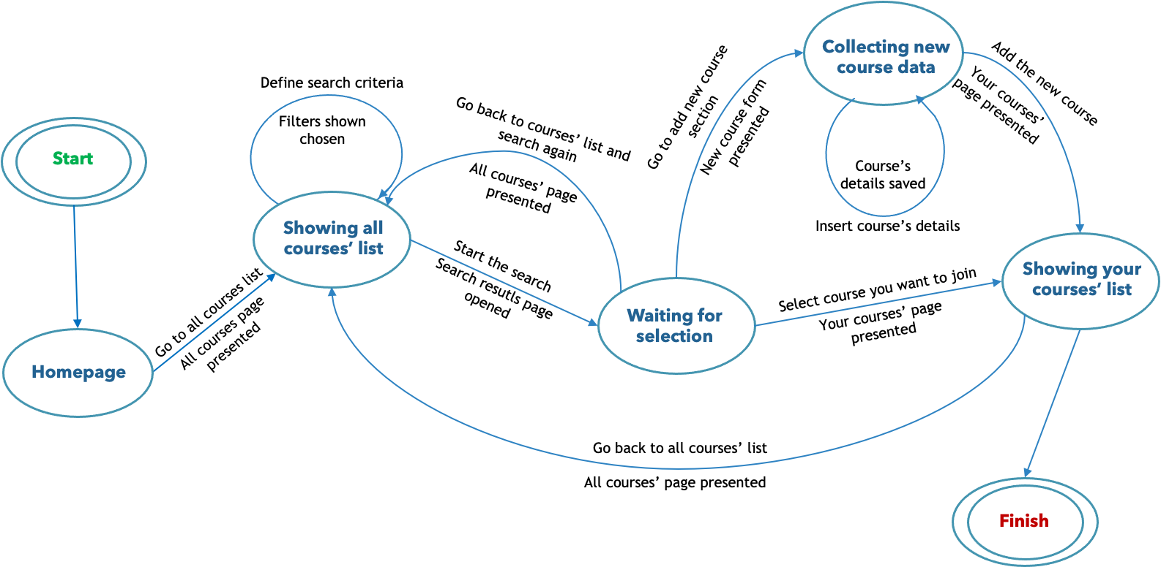

*Figure 33. Select course to join STN*

* 1. **Manage course’s notification**

The user manages notifications’ course in order to:

1. Be or not to be notified about the beginning of the lessons;
2. Be or not to be notified about the homework’s deadlines;
3. Be or not to be notified about exam’s events;

To manage the course’s notification, he before has to select the course and then activate or deactivate the wanted notifications.



*Figure 34. Manage course’s notification HTA*

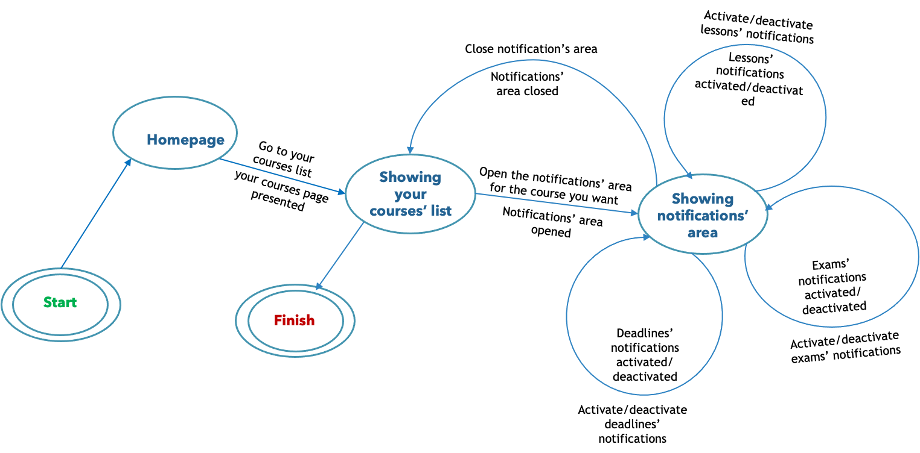

*Figure 35. Manage course’s notification STN*

* 1. **Take-Share Notes**

The user wants to take notes using the application in order to:

1. Write them in a clearer and more orderly way;
2. Always have them at hand using smartphone or PC;
3. Share them with the other colleagues;

To manage this he first goes to the section «Take Note», then once the note is written he can decide to share it or not, he can also

decide to share it later.



*Figure 36. Take-Share Notes HTA*

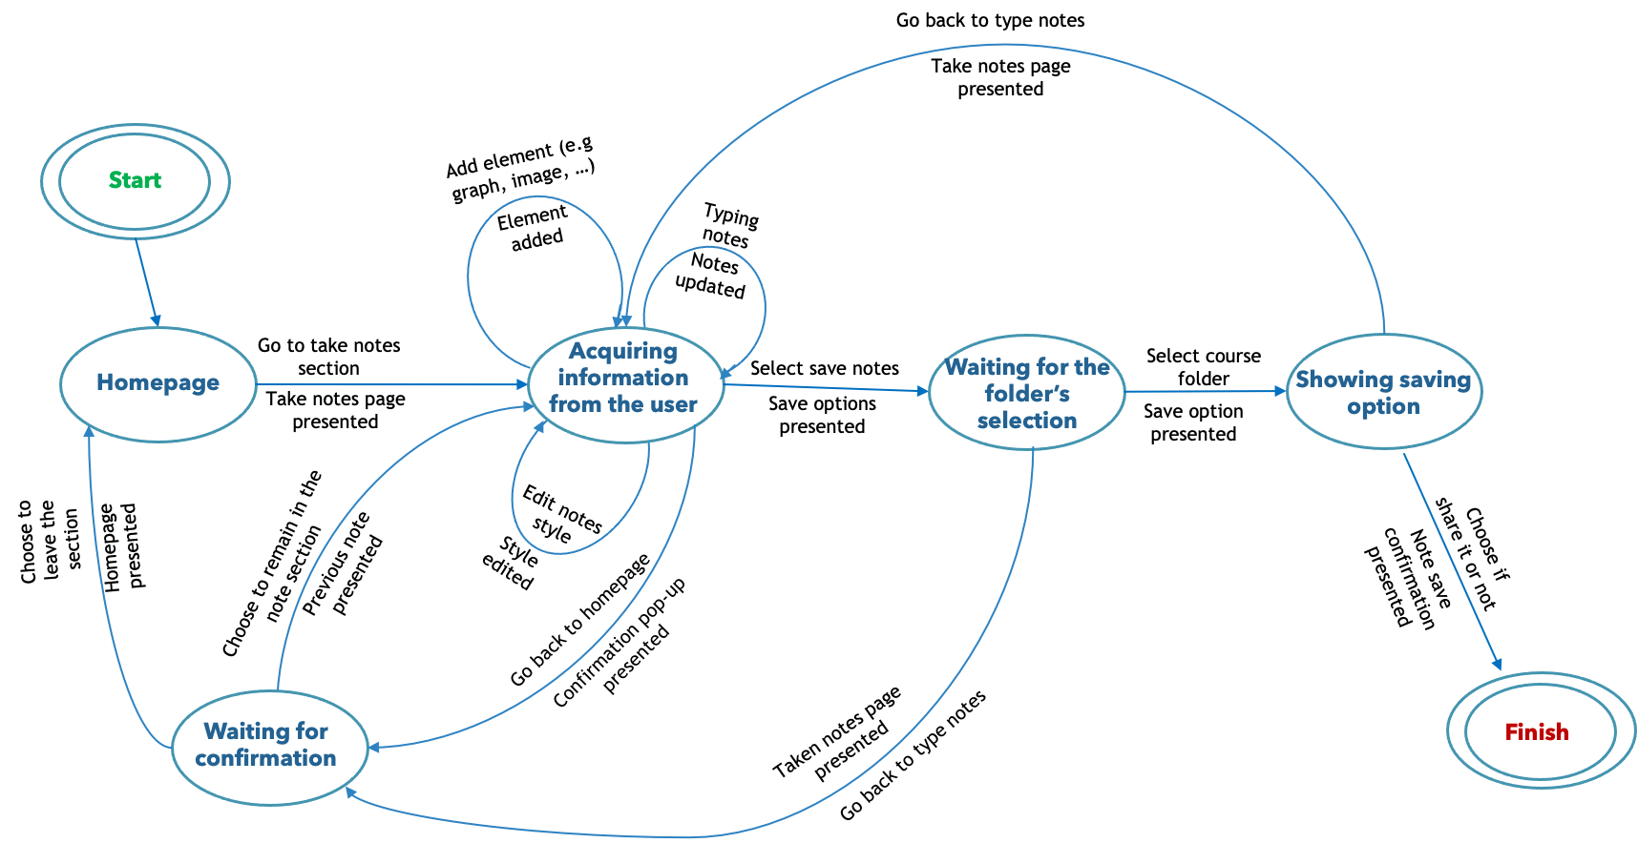

*Figure 37. Take-Share Notes STN*

* 1. **Find-Rank notes**

The user wants to search notes already taken by other students on the application in order to:

1. Find good notes shared by his colleagues;
2. Always have them at hand using smartphone or PC;
3. Rank them so that he can share with other users how useful they are;

In order to find notes, the user at first has to go to the section *Shared Notes*, then he searches the notes by applying some filters. Once he finds the notes he was looking for, he can mark them and/or save them.

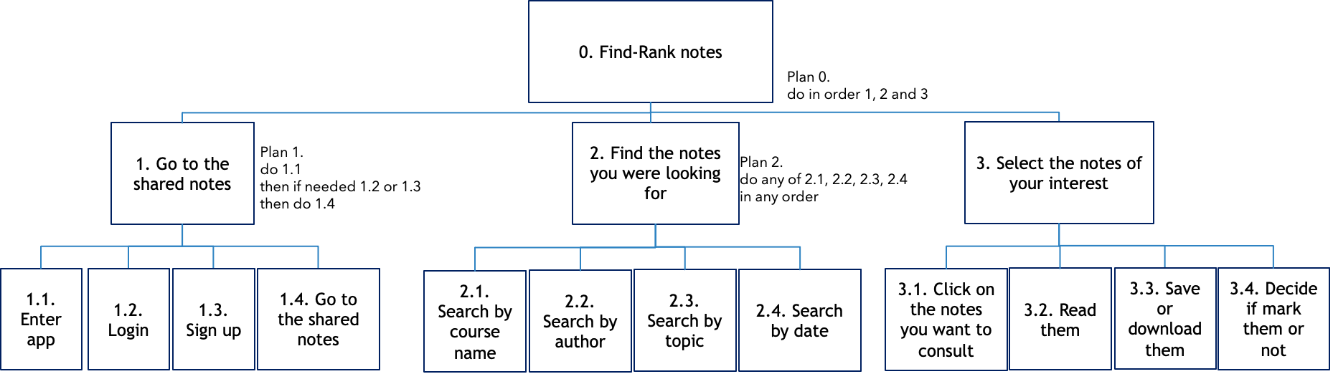

*Figure 38. Find-Rank Notes HTA*

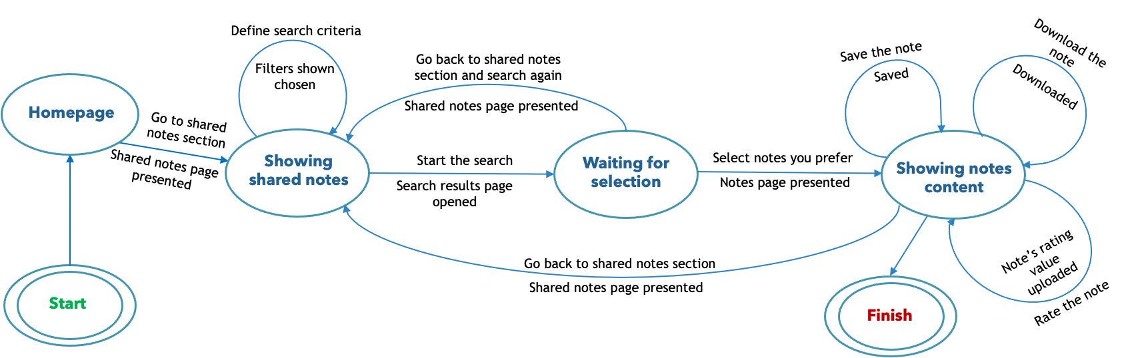

*Figure 39. Find-Rank Notes STN*

* 1. **Add course information**

The user (administrator of a course) wants add or change course’s information related to:

1. Course’s website;
2. Social channels students usually use to talks about the course;
3. Link for the online lessons;
4. Course’s lessons schedule;
5. Deadlines;

In order to do that, a student has to be the administrator of the course. He has to select the course he wants to manage information, edit the course’s information and save changes.

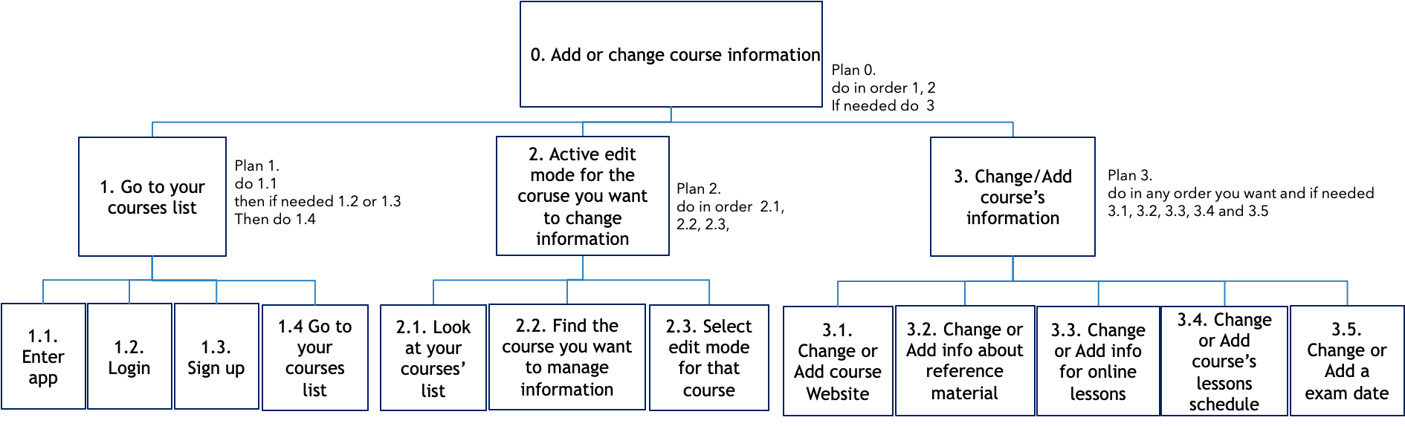

*Figure 40. Add course information HTA*

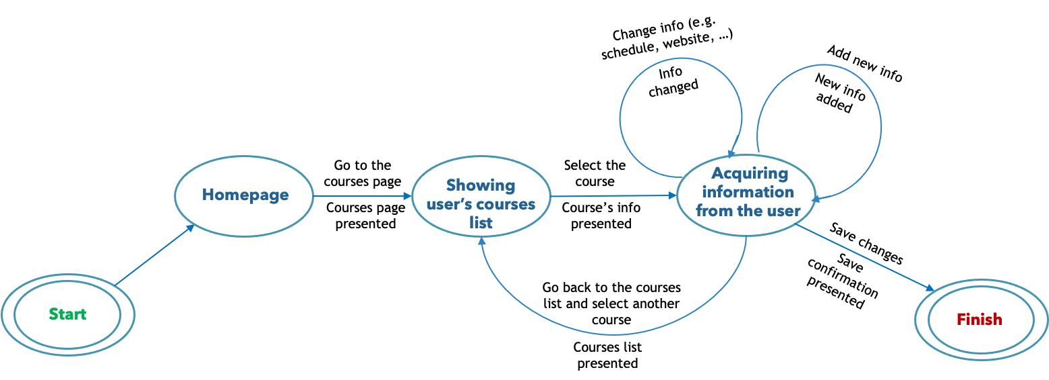

*Figure 41. Add course information STN*

1. **Prototype 0**

In this chapter we are going to present the UNINOTE first prototype. Analyzing the results we got from the questionnaires, we have decided which features the system has to provide while HTA and STN gave us a detailed description of the behavior our application should have. Thanks to questionnaires analysis we know our application should be available in both mobile and desktop versions. Indeed, a mobile application is really useful if we think about the close relationship there is, nowadays, between people and phones. Considering the hectic students’ life, to have all information students need at hand is really helpful! Students always spend a lot of time by standing outside the house and they usually do not always have their laptop at hand. Being notify by your phone about university stuff will be more powerful since people have their phone with them at all times.

Otherwise, a desktop version is needed if we think about taking notes functionalities. A lot of students are used to take notes by laptop and it is really uncomfortable to use phone.

The following prototype was realized through mock-up. It has an essential graphic interface with familiar icons. In this way users can exploit their knowledge of other application which uses similar icons. The entire prototype is dynamic, so user can interact with it.

 





 











1. **Expert based evaluation**

The role of the evaluation is to assess our design and test our system, it should occur throughout the design life cycle, with the result of the evaluation feeding back into modifications to the design. Typically, the later in the design process that an error is discovered, the more costly it is to put right, in order to avoid user testing at regular intervals (because it could be very expensive), so a number of methods were born to evaluate systems through expert analysis (cheaper because don’t require user involvement).

* 1. **Cognitive Walkthrough**

Walkthroughs require a detailed review of a sequence of actions, that in this case refers to the steps that an interface will require a user to perform in order to accomplish some known tasks. The main focus is to establish how easy a system is to learn (so learning from exploration) because many users prefer to learn a system by exploring it instead of with the user’s manual. The expert in this case succeeds in identifying potential problems using psychological principles.

To perform a cognitive walkthrough you need 4 elements:

* A specification or prototype of the system;
* A description of the task the user has to perform on the system;
* A list of actions needed to complete the task proposed;
* An indicator of who is the user and his level of knowledge;

For each action the expert will try to answer 4 fundamental questions (presented below in our evaluation).

For our project the evaluation was done by Valeria Mirabella (tutor of the course):

* **Task 1.a:** add the course *Human-Computer Interaction* (present in the courses list***)***to your courses list.

|  |
| --- |
| **Action1: press the button *“Join a new course”* in the *“My Courses”* page.** |
| **Question 1:** *Is the effect of the action the same as the user’s goal at that point?*  **Answer 1: yes** |
| **Question 2:** *Will users see that the action is available?*  **Answer 2: yes** |
| **Question 3:** *Once users have found the correct action, will they know it is the one they need?*  **Answer 3: yes** |
| **Question 4:** *After the action is taken, will users understand the feedback they get?*  **Answer 4: yes** |
| **Action 2: scroll the courses list in the page *“Courses list”* until you find the *Human-Computer Interaction* course. You can also search by typing the name/code of the course in the input text area.** |
| **Question 1:** *Is the effect of the action the same as the user’s goal at that point?*  **Answer 1: yes** |
| **Question 2:** *Will users see that the action is available?*  **Answer 2: yes** |
| **Question 3:** *Once users have found the correct action, will they know it is the one they need?*  **Answer 3: yes** |
| **Question 4:** *After the action is taken, will users understand the feedback they get?*  **Answer 4: yes** |
| **Action 3: click on the *“+”* symbol near the name of the course in order to add this course to your courses list.** |
| **Question 1:** *Is the effect of the action the same as the user’s goal at that point?*  **Answer 1: yes** |
| **Question 2:** *Will users see that the action is available?*  **Answer 2: yes** |
| **Question 3:** *Once users have found the correct action, will they know it is the one they need?*  **Answer 3:** It is not clear which button/function to be used. The user could use the “+” in the course line or he/she can be supposed to select somehow the course and use “Add new course” function. |
| **Question 4:** *After the action is taken, will users understand the feedback they get?*  **Answer 4:** A distracted user could not understand the feedback. I will probably look for a confirmation message |

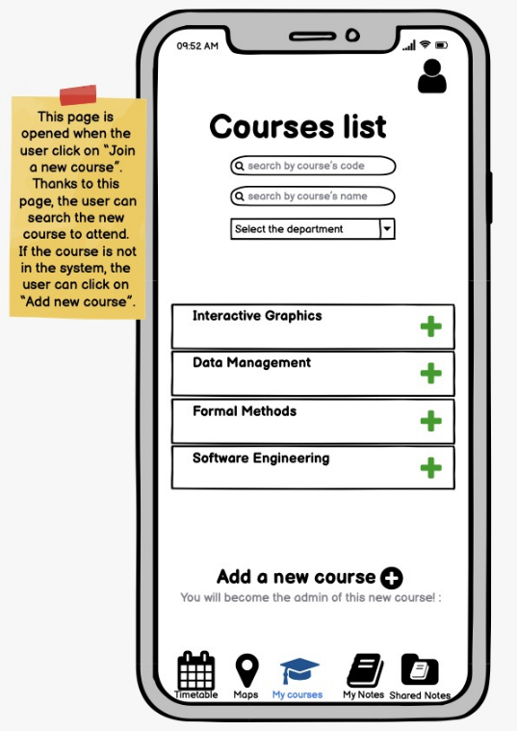 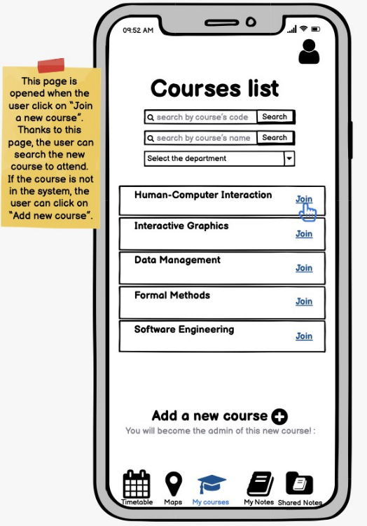

In order to disambiguate the ‘+’ icon of add new course and join a new course we decided to substitute the ‘+’ of the join functionality with a button which is clearer for the user.

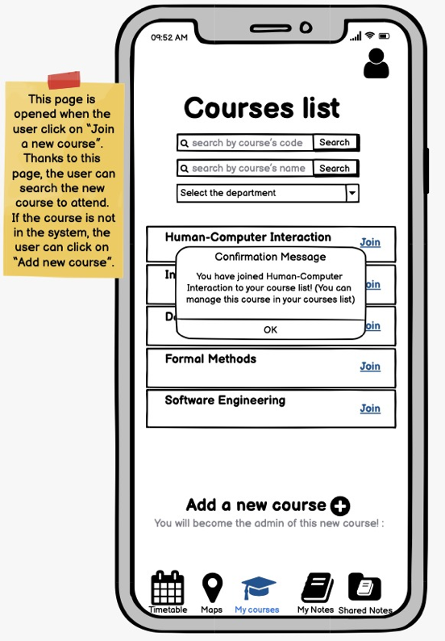

We also added a confirmation message as feedback once a course is joined, as suggested by the expert.

* **Task 1.b:** add the course *Human-Computer Interaction* (not present in the courses list***)***to your couses list.

|  |
| --- |
| **Action1: press the button *“Join a new course”* in the *“My Courses”* page.** |
| **Question 1:** *Is the effect of the action the same as the user’s goal at that point?*  **Answer 1: yes** |
| **Question 2:** *Will users see that the action is available?*  **Answer 2: yes** |
| **Question 3:** *Once users have found the correct action, will they know it is the one they need?*  **Answer 3: yes** |
| **Question 4:** *After the action is taken, will users understand the feedback they get?*  **Answer 4: yes** |
| **Action 2: scroll the courses list in the page *“Courses list”* until you find the *Human-Computer Interaction* course. You can also search by typing the name/code of the course in the input text area.** |
| **Question 1:** *Is the effect of the action the same as the user’s goal at that point?*  **Answer 1: yes** |
| **Question 2:** *Will users see that the action is available?*  **Answer 2: yes** |
| **Question 3:** *Once users have found the correct action, will they know it is the one they need?*  **Answer 3: yes** |
| **Question 4:** *After the action is taken, will users understand the feedback they get?*  **Answer 4: yes** |
| **Action 3: since you do not find the course of your interest, click on *“Add new course”* button.** |
| **Question 1:** *Is the effect of the action the same as the user’s goal at that point?*  **Answer 1: yes** |
| **Question 2:** *Will users see that the action is available?*  **Answer 2:** It is not clear which button/function to be used. If the course is not in the list the user could use the search function to look for it or the “Add new course” function. |
| **Question 3:** *Once users have found the correct action, will they know it is the one they need?*  **Answer 3: yes** |
| **Question 4:** *After the action is taken, will users understand the feedback they get?*  **Answer 4: yes** |
| **Action 4: fill the form with all the infos about the course of *Human-Computer Interaction*.** |
| **Question 1:** *Is the effect of the action the same as the user’s goal at that point?*  **Answer 1: yes** |
| **Question 2:** *Will users see that the action is available?*  **Answer 2: yes** |
| **Question 3:** *Once users have found the correct action, will they know it is the one they need?*  **Answer 3: yes** |
| **Question 4:** *After the action is taken, will users understand the feedback they get?*  **Answer 4: yes** |
| **Action 5: click the *“Add”* button in order to save changes.** |
| **Question 1:** *Is the effect of the action the same as the user’s goal at that point?*  **Answer 1: yes** |
| **Question 2:** *Will users see that the action is available?*  **Answer 2: yes** |
| **Question 3:** *Once users have found the correct action, will they know it is the one they need?*  **Answer 3: yes** |
| **Question 4:** *After the action is taken, will users understand the feedback they get?*  **Answer 4:** a distracted user could not understand the feedback. I will probably look for a confirmation message |
| **Action 6: scroll the courses list in the page *“Courses list”* and search the *Human-Computer Interaction* course, which you have already added.** |
| **Question 1:** *Is the effect of the action the same as the user’s goal at that point?*  **Answer 1: yes** |
| **Question 2:** *Will users see that the action is available?*  **Answer 2: yes** |
| **Question 3:** *Once users have found the correct action, will they know it is the one they need?*  **Answer 3: yes** |
| **Question 4:** *After the action is taken, will users understand the feedback they get?*  **Answer 4: yes** |
| **Action 7: click on the *“+”* symbol near the name of the course in order to add this course to your courses list.** |
| **Question 1:** *Is the effect of the action the same as the user’s goal at that point?*  **Answer 1: yes** |
| **Question 2:** *Will users see that the action is available?*  **Answer 2: yes** |
| **Question 3:** *Once users have found the correct action, will they know it is the one they need?*  **Answer 3:** It is not clear which button/function to be used. If the course is not in the list the user could use the search function lo look for it or the “Add new course” function. |
| **Question 4:** *After the action is taken, will users understand the feedback they get?*  **Answer 4:** a distracted user could not understand the feedback. Hi will probably look for a confirmation message |

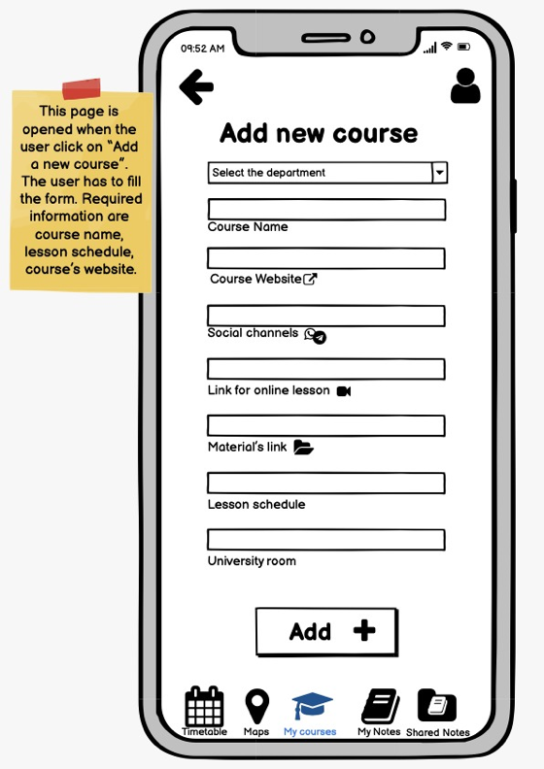 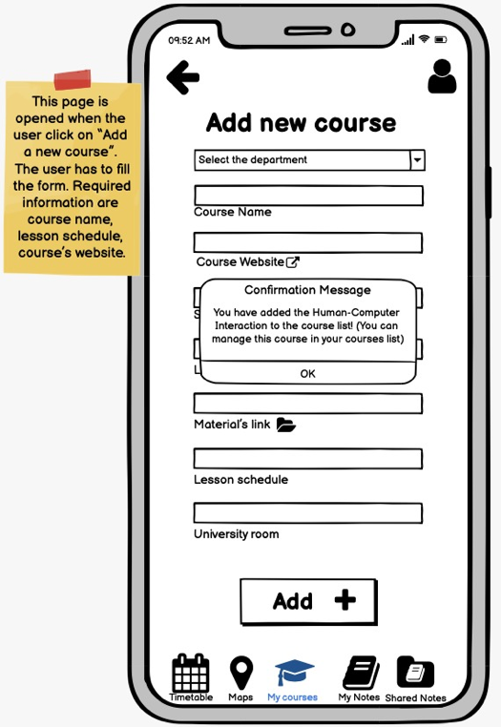

We add a confirmation message as feedback once the course is added to the courses list, as suggested by the expert. Then in order to solve the other problems about the action described, we decided to simplify the entire operation, since this task is one of the most important and so needs to be fast and simple. At the beginning, once a new course was added then the user was directed to the ‘All course list’ page and he had to join the course he had just added, now these two steps are unified, so when the user adds the new course it’s also joins it.

* **Task 2:** switch on lesson’s notifications for the *Human-Computer Interaction* course.

|  |
| --- |
| **Action1: press “my courses” button from the navigation bar.** |
| **Question 1:** *Is the effect of the action the same as the user’s goal at that point?*  **Answer 1: yes** |
| **Question 2:** *Will users see that the action is available?*  **Answer 2: yes** |
| **Question 3:** *Once users have found the correct action, will they know it is the one they need?*  **Answer 3: yes** |
| **Question 4:** *After the action is taken, will users understand the feedback they get?*  **Answer 4: yes** |
| **Action 2: scroll the courses’ list or click on the search field and type the name of the course “Human Computer Interaction”.** |
| **Question 1:** *Is the effect of the action the same as the user’s goal at that point?*  **Answer 1: yes** |
| **Question 2:** *Will users see that the action is available?*  **Answer 2: yes** |
| **Question 3:** *Once users have found the correct action, will they know it is the one they need?*  **Answer 3: yes** |
| **Question 4:** *After the action is taken, will users understand the feedback they get?*  **Answer 4: yes** |
| **Action 3: click on the bell button inside the Human Computer Interaction course’s box** |
| **Question 1:** *Is the effect of the action the same as the user’s goal at that point?*  **Answer 1: yes** |
| **Question 2:** *Will users see that the action is available?*  **Answer 2: yes** |
| **Question 3:** *Once users have found the correct action, will they know it is the one they need?*  **Answer 3:** I think yes, the bell icon if widely used. |
| **Question 4:** *After the action is taken, will users understand the feedback they get?*  **Answer 4: yes** |
| **Action 4: click on the on/off button for the lessons’ notifications** |
| **Question 1:** *Is the effect of the action the same as the user’s goal at that point?*  **Answer 1: yes** |
| **Question 2:** *Will users see that the action is available?*  **Answer 2: yes** |
| **Question 3:** *Once users have found the correct action, will they know it is the one they need?*  **Answer 3: yes** |
| **Question 4:** *After the action is taken, will users understand the feedback they get?*  **Answer 4: yes** |

* **Task 3:** Share a note regarding the course of *Human-Computer Interaction* to everyone following the course.

|  |
| --- |
| **Action1: Select the *Human-Computer Interaction* folder on *“My Notes”* page** |
| **Question 1:** *Is the effect of the action the same as the user’s goal at that point?*  **Answer 1: yes** |
| **Question 2:** *Will users see that the action is available?*  **Answer 2: yes** |
| **Question 3:** *Once users have found the correct action, will they know it is the one they need?*  **Answer 3: yes** |
| **Question 4:** *After the action is taken, will users understand the feedback they get?*  **Answer 4: yes** |
| **Action 2: search and select the note in the page *Human-Computer Interaction page* that you want to share, you can also search applying filters or by typing in the text area** |
| **Question 1:** *Is the effect of the action the same as the user’s goal at that point?*  **Answer 1: yes** |
| **Question 2:** *Will users see that the action is available?*  **Answer 2: yes** |
| **Question 3:** *Once users have found the correct action, will they know it is the one they need?*  **Answer 3: yes** |
| **Question 4:** *After the action is taken, will users understand the feedback they get?*  **Answer 4: yes** |
| **Action 3: click on the *“Share”* button on the bottom of the page in order to share the note with the other classmates in the *“Shared notes”* section.** |
| **Question 1:** *Is the effect of the action the same as the user’s goal at that point?*  **Answer 1: yes** |
| **Question 2:** *Will users see that the action is available?*  **Answer 2: yes** |
| **Question 3:** *Once users have found the correct action, will they know it is the one they need?*  **Answer 3: yes** |
| **Question 4:** *After the action is taken, will users understand the feedback they get?*  **Answer 4: yes** |

* **Task 4:** Take a new note regarding the course of *Human-Computer Interaction* directly using the desktop application.

|  |
| --- |
| **Action1: Press the *“Take note”* button on the navigation bar.** |
| **Question 1:** *Is the effect of the action the same as the user’s goal at that point?*  **Answer 1: yes** |
| **Question 2:** *Will users see that the action is available?*  **Answer 2: yes** |
| **Question 3:** *Once users have found the correct action, will they know it is the one they need?*  **Answer 3: yes** |
| **Question 4:** *After the action is taken, will users understand the feedback they get?*  **Answer 4: yes** |
| **Action 2: Type the note in the proper section.** |
| **Question 1:** *Is the effect of the action the same as the user’s goal at that point?*  **Answer 1: yes** |
| **Question 2:** *Will users see that the action is available?*  **Answer 2: yes** |
| **Question 3:** *Once users have found the correct action, will they know it is the one they need?*  **Answer 3: yes** |
| **Question 4:** *After the action is taken, will users understand the feedback they get?*  **Answer 4: yes** |
| **Action 3: Click on the graph icon in order to insert a graph in the note section.** |
| **Question 1:** *Is the effect of the action the same as the user’s goal at that point?*  **Answer 1: yes** |
| **Question 2:** *Will users see that the action is available?*  **Answer 2: yes** |
| **Question 3:** *Once users have found the correct action, will they know it is the one they need?*  **Answer 3: yes** |
| **Question 4:** *After the action is taken, will users understand the feedback they get?*  **Answer 4: yes** |
| **Action 4: Once finished to write the note click on the *“Check”* symbol to save the note.** |
| **Question 1:** *Is the effect of the action the same as the user’s goal at that point?*  **Answer 1: yes** |
| **Question 2:** *Will users see that the action is available?*  **Answer 2: yes** |
| **Question 3:** *Once users have found the correct action, will they know it is the one they need?*  **Answer 3: yes** |
| **Question 4:** *After the action is taken, will users understand the feedback they get?*  **Answer 4: yes** |
| **Action 5: Click on *“No keep it private”* box** |
| **Question 1:** *Is the effect of the action the same as the user’s goal at that point?*  **Answer 1: yes** |
| **Question 2:** *Will users see that the action is available?*  **Answer 2: yes** |
| **Question 3:** *Once users have found the correct action, will they know it is the one they need?*  **Answer 3: yes** |
| **Question 4:** *After the action is taken, will users understand the feedback they get?*  **Answer 4: yes** |

* **Task 5:** Find a shared note regarding the course of *Human-Computer Interaction* and rank it.

|  |
| --- |
| **Action1: Select the *Human-Computer Interaction* folder on *“Share Notes”* page.** |
| **Question 1:** *Is the effect of the action the same as the user’s goal at that point?*  **Answer 1: yes** |
| **Question 2:** *Will users see that the action is available?*  **Answer 2: yes** |
| **Question 3:** *Once users have found the correct action, will they know it is the one they need?*  **Answer 3: yes** |
| **Question 4:** *After the action is taken, will users understand the feedback they get?*  **Answer 4: yes** |
| **Action 2: earch and select the shared note in the page *Human-Computer Interaction page* that you want to share, you can also search applying filters or by typing in the text area.** |
| **Question 1:** *Is the effect of the action the same as the user’s goal at that point?*  **Answer 1: yes** |
| **Question 2:** *Will users see that the action is available?*  **Answer 2: yes** |
| **Question 3:** *Once users have found the correct action, will they know it is the one they need?*  **Answer 3: yes** |
| **Question 4:** *After the action is taken, will users understand the feedback they get?*  **Answer 4: yes** |
| **Action 3: click on one of the *“second star“*  buttons on the bottom of the page in order to give a rank of the shared note** |
| **Question 1:** *Is the effect of the action the same as the user’s goal at that point?*  **Answer 1: yes** |
| **Question 2:** *Will users see that the action is available?*  **Answer 2: yes** |
| **Question 3:** *Once users have found the correct action, will they know it is the one they need?*  **Answer 3: yes** |
| **Question 4:** *After the action is taken, will users understand the feedback they get?*  **Answer 4: yes** |

* 1. **Heuristic Evaluation**

A heuristic is a guideline or general principle or rule of thumb that can guide a design decision or be used to critique a decision that has been made. Heuristic evaluation can be useful for evaluate early design but can be used also in fully functioning systems, so is a flexible and relatively cheap approach. It’s usually done by different evaluators independently; in our case the evaluation has been done by Valeria Mirabella.

The heuristic evaluation is based on Nielsen’s ten heuristics, that are:

* 1. **Visibility of system status**: Always keep users informed about what is going on, through appropriate feedback within reasonable time.

1. **Match between system and the real world:** The system should speak the user’s

language, with words, phrases and concepts familiar to the user, rather than

system-oriented terms.

1. **User control and freedom**: Users often choose system functions by mistake

and need a clearly marked ‘emergency exit’ to leave the unwanted state without

having to go through an extended dialog. Support undo and redo.

1. **Consistency and standards**: Users should not have to wonder whether words,

situations or actions mean the same thing in different contexts.

1. **Error prevention**: Make it difficult to make errors. Even better than good error

messages is a careful design that prevents a problem from occurring in the first

place.

1. **Recognition rather than recall:** Make objects, actions and options visible. The

user should not have to remember information from one part of the dialog to

another.

1. **Flexibility and efficiency of use:** Allow users to tailor frequent actions.

Accelerators – unseen by the novice user – may often speed up the interaction

for the expert user.

1. **Aesthetic and minimalist design:** Dialogs should not contain information that

is irrelevant or rarely needed.

1. **Help users recognize, diagnose and recover from errors:** Error messages should

be expressed in plain language (no codes), precisely indicate the problem, and

constructively suggest a solution.

1. **Help and documentation:** Few systems can be used with no instructions so it

may be necessary to provide help and documentation. Any such information

should be easy to search.

The date of our evaluation is 24/05/2021, it was divided in two parts, the first one was performed with other students and the latter through the evaluation of the expert Valeria Mirabella and the final result is:

|  |  |  |  |
| --- | --- | --- | --- |
| Frame | Heuristic violated | Severity | Description / Comment |
| My courses | Error prevention | 3 | Make clear how to start the search |
| My courses | Aesthetic and minimalist design | 2 | The page is full of information. Consider to prioritize relevant information and use hierarchy. |
| Edit note | Error prevention | 3 | Consider to add a confirmation message |

The severity rating scale is:

0 = I don’t agree that this is a usability problem at all.

1 = Cosmetic problem only: need not be fixed unless extra time is available on project.

2 = Minor usability problem: fixing this should be given low priority.

3 = Major usability problem: important to fix, so should be given high priority.

4 = Usability catastrophe: imperative to fix this before product can be released.

1. **Prototype 1**

The second prototype is obtained after the correction of the defects of the first prototype and it is the result of the Cognitive Walkthrough evaluation. Even this second prototype has been realized through mock-up and it presents an essential graphic interface with familiar icons. The entire prototype is dynamic and it was realized through the Balsamiq tool. Thanks to this evaluation we have corrected the defects of the first prototype in order to make the use of our application easier and more intuitive. The improvements made are:

* Substitution of the ‘+’ icon of join a new course with a button which is clearer for the user;
* Addition of ‘Search’ button in order to make the searching for a course more intuitive;



* Addition of a confirmation message as feedback once a course is joined;
* Addition of a confirmation message as feedback once a new course is added.



1. **Prototype 2**

The third prototype is obtained after the Heuristic evaluation. Thus, we have corrected the defects of the second prototype. Even this third prototype has been realized through mock-up and it presents an essential graphic interface with familiar icons. The entire prototype is dynamic and it was realized through the Balsamiq tool. Thanks to this evaluation we have improved the second prototype. The corrections made are:

* Addition of the search bar, so that the user can search for a course in his personal courses list. This small change is due to the result of the heuristic evaluation because was no clear how to start the search;



* Deleting the details of a course from the ‘My Courses’ page. Thus, the page is no longer full of information and if the user wants to read info of a specific course, he has to click on the course name and so he is redirected to the page containing the course’s info. Even this result is due to the Heuristic evaluation, which showed a high level of severity for the aesthetic and minimalist design of the page;
* From the Heuristic Evaluation we decided to add a confirmation message after the editing of a note, in order to make clear to the user that the task has been completed in the right way.

1. **User based evaluation**

The evaluation techniques that have been used since now, concentrate on evaluating a design of the system through analysis by an expert evaluator. These evaluations, even if they are useful, do not involve the people for whom the system is intended. User based evaluations consist of approaches to evaluate through user participation.

One of the most used way to gather information about actual use of the system is to observe users interacting with it.

We have decided to use think aloud and cooperative evaluation as observation techniques.

* 1. **Think aloud**

In order to perform a think aloud the user is asked to perform a task and to talk through what he is doing.

We chose a group of 6 people of different ages according to the user profile, and performed the experiment using the following criteria:

* We explained to the users who we are and what we are doing specifying we were testing our application and not testing them;
* Each member has to accomplish the same task individually, we choose two tasks that users have to perform;
* The experiment took place in a room without distractions, and each person had a smartphone with UNINOTE installed;
* During the experiment, we recorded the actions performed by the user thanks to a screen recording and we took note writing of paper the encountered problems and the difficulties;
  + 1. **Task1: View a course’s details**

Each member of the group was asking to perform the following task: let’s know what is the Data Management course’s web page in order to read the professor communications.

The users reported two problems. We have summarized the experiment’s flow and some our considerations in the following schema:



* + 1. **Task2: Know the lesson’s schedule**

From the group emerged that most of them find vital to use the timetable the first weeks of lessons, because of the difficulty in remembering all the courses day and time, so performs the task of examining the timetable.

The users reported only a problem. We have summarized the experiment’s flow and some our considerations in the following schema:



* 1. **Cooperative evaluation**

The cooperative evaluation is a variation of think aloud where the user is encouraged to see himself as a collaborator in the evaluation and not simply as an experimental participant. The evaluator can ask the user questions if his behaviour is unclear and the user can ask clarification on problems. The evaluation is always recorded, this is known as ‘protocol’, and then there must be done a protocol analysis.

* + 1. **Task1: Save favourite note and open it**

One of the most interesting features that our application provides is the opportunity to save a good note once you find it, in order to avoid the necessity of searching it each time. From the analysis with the users only a problem emerged:



* 1. **Controlled Experiment**

The controlled experiment provides empirical evidence to support a particular claim or hypothesis. The evaluator chooses a hypothesis to test, then a number of conditions are considered, there are a lot of factors to be considered that includes the participants chosen, the variables tested and manipulated, and the hypothesis tested.

* + 1. **Participants**

The participants should be chosen to match the expected user population as closely as possible. The sample size must be large enough to be considered to be representative of the population, in fact Nielsen and Landauer stated that a test with a single participant will find out about a third of the usability problems.

* + 1. **Variables**

There are two kinds of variables: independent (those that are manipulated or change) and dependent (those that are measured). The independent ones are manipulated to produce different level of comparisons (like the interface style and icon design) while the dependent are measured during an experiment, so their value depends on change made to independent variables.

* + 1. **Hypothesis**

An hypothesis is a prediction of the outcome of an experiment, the aim of the experiment is to show that this prediction is correct, this is done by disproving the null hypothesis, which states that there is no difference in the dependent variable between the levels of the independent variables.

* + 1. **Experimented Details**

There are two different experimental method that can be used: between-subjects and within-subjects. In between-subjects, each participant is assigned to a different condition, the advantage in this case is that any user performs under only one condition, so it requires a great number of participants. In within-subject each user performs under different condition, it requires fewer users so it is less costly.

* + 1. **ANOVA**

Once we have determined all the above factors, we need to decide how to analyze the results we record, there are a lot of statistical test available, what we chose is ANOVA (that is ANalysis Of VAriance). Once we have collected the needed data, we ran an ANOVA (analysis of variance) single factor statistical analysis on them. ANOVA single factor can be used to compare the means between two or more groups of values. Thus, thanks to this statistical test, we can understand if some data are statistical relevant or not. In order to do the analysis of variance, we used the plugin offered by Excel.

**Task 1: Save note as favorite**

The user is reading a note that interests him and he wants to save it as favorite;

* Participants: 20 people in the range of age between 19-25 years old according to user profile;
* Variables: The 2 interfaces (independent) and the time in second to execute the task (dependent);
* Hypothesis: User will complete the task in less time using the first interface than the second one;
* Assumption: Let’s assume the user is already logged in the application.



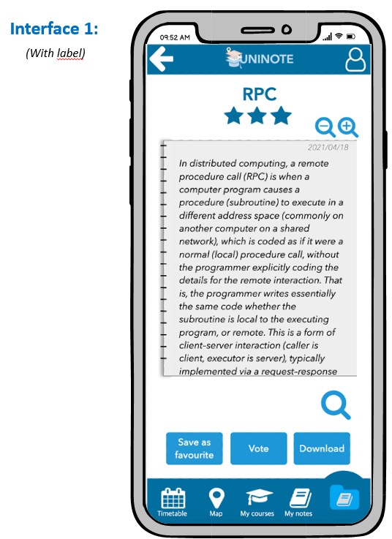 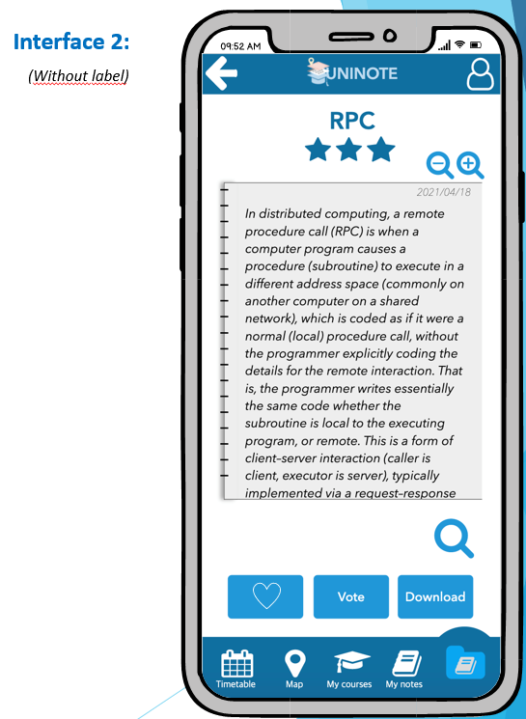

**Task 2: Search building on the map**

The user wants to know where a specific building is located on the map;

* Participants: 20 people in the range of age between 19-25 years old according to user profile;
* Variables: The 2 interfaces (independent) and the time in second to execute the task (dependent);
* Hypothesis: User will complete the task in less time using the first interface than the second one;
* Assumption: Let’s assume the user is already logged in the application.



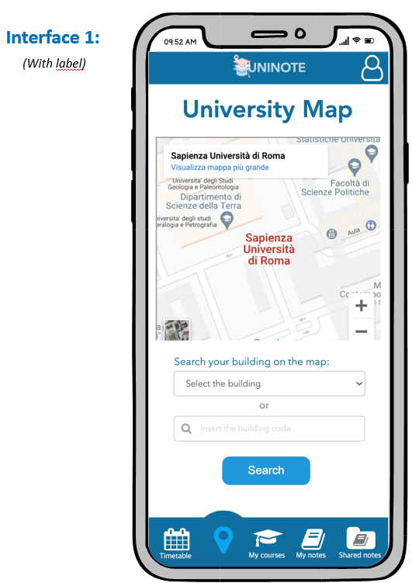 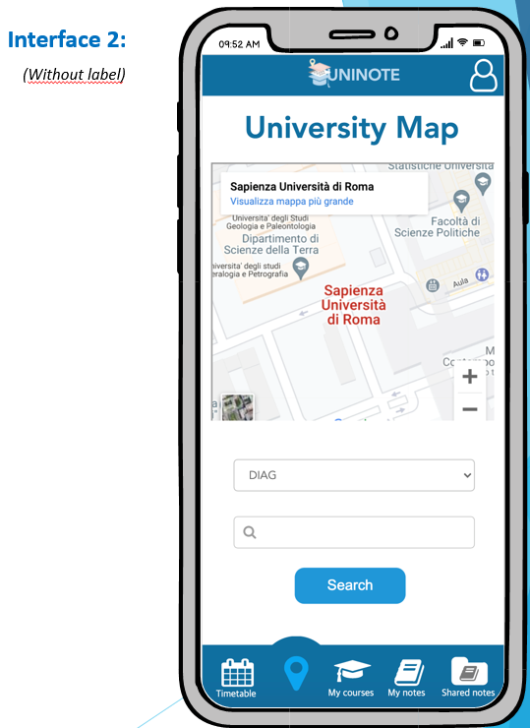

**Task 3: Open a course’s details**

The user wants to see course’s details (e.g.: lessons’ link, reference web page, etc...);

* Participants: 20 people in the range of age between 19-25 years old according to user profile;
* Variables: The 2 interfaces (independent) and the time in second to execute the task (dependent);
* Hypothesis: User will complete the task in less time using the first interface than the second one;
* Assumption: Let’s assume the user is already logged in the application.

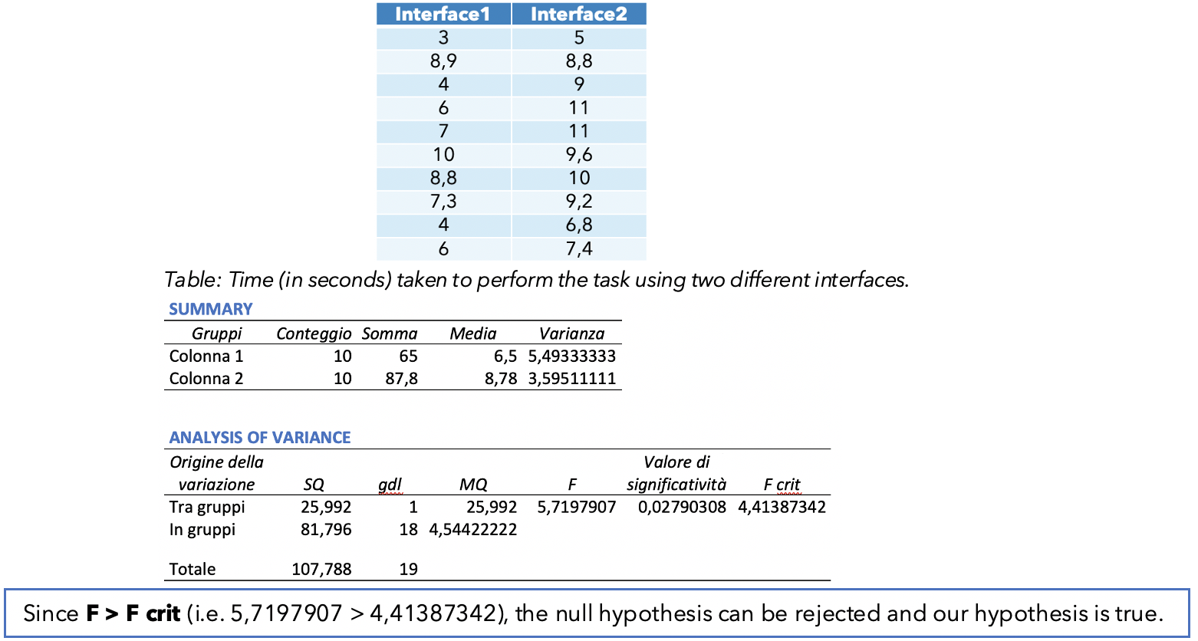 

1. **Prototype 3**

The fourth prototype is obtained after the user-based evaluation. Thus, we have corrected the defects of the third prototype. Even this fourth prototype has been realized through mock-up and it presents an essential graphic interface with familiar icons. Thanks to this evaluation we have improved the third prototype. The corrections made are:

* 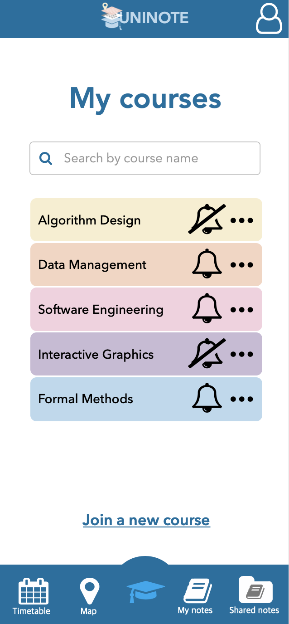Addition of shadow, so that the user can better understand he can click on the course name to read its details. We made this change after doing the Controlled Experiment (with ANOVA). Therefore, the results of this evaluation made us opt for using this interface with shadows;

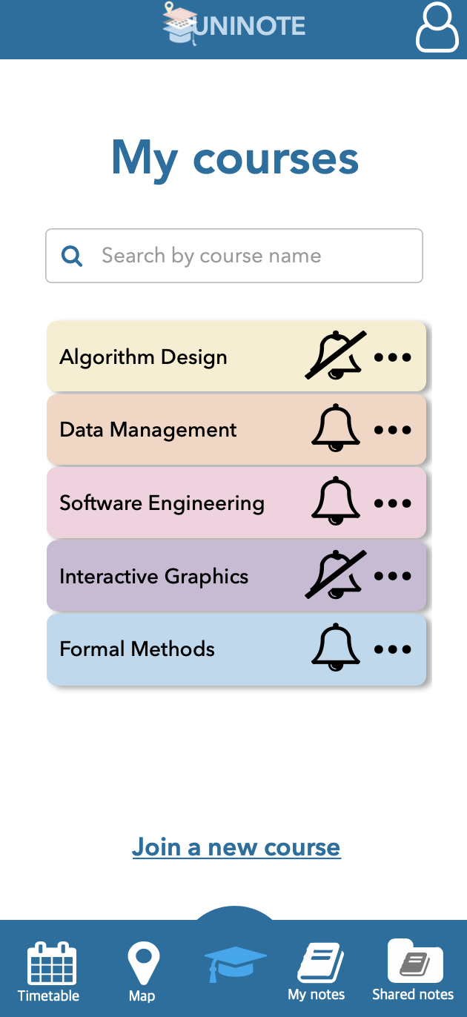

* Addition of a short description of the links, so the user can better understand what they are for. We made this change after the Think Aloud evaluation. The result of this user based evaluation is that the user has difficulty understanding the difference between the various links;



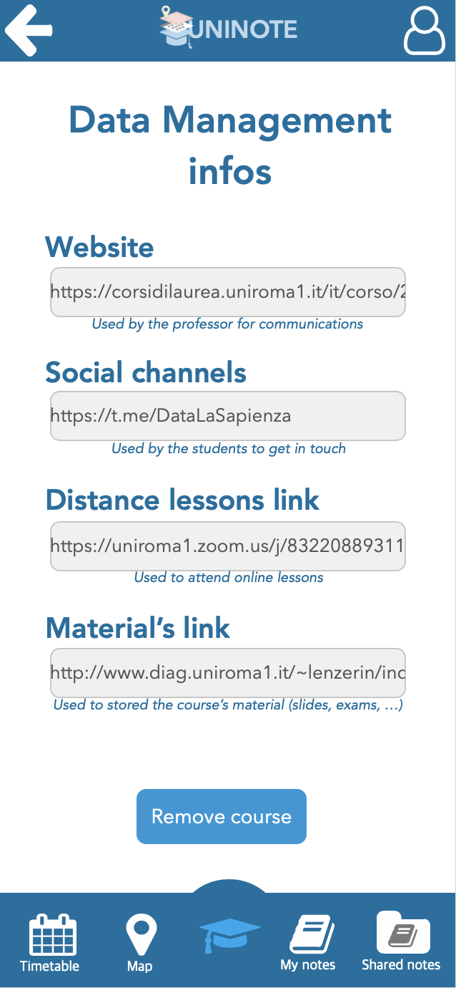

* Addition of a message which helps the user to access the My favorite courses’

List. We made this change after the Cooperative Evaluation. We decided to do this type of evaluation rather than the Think Aloud because we were interested in knowing which clarifications users could ask. The result is that we added a more detailed pop up in which we explain users where they can find the favourite notes;



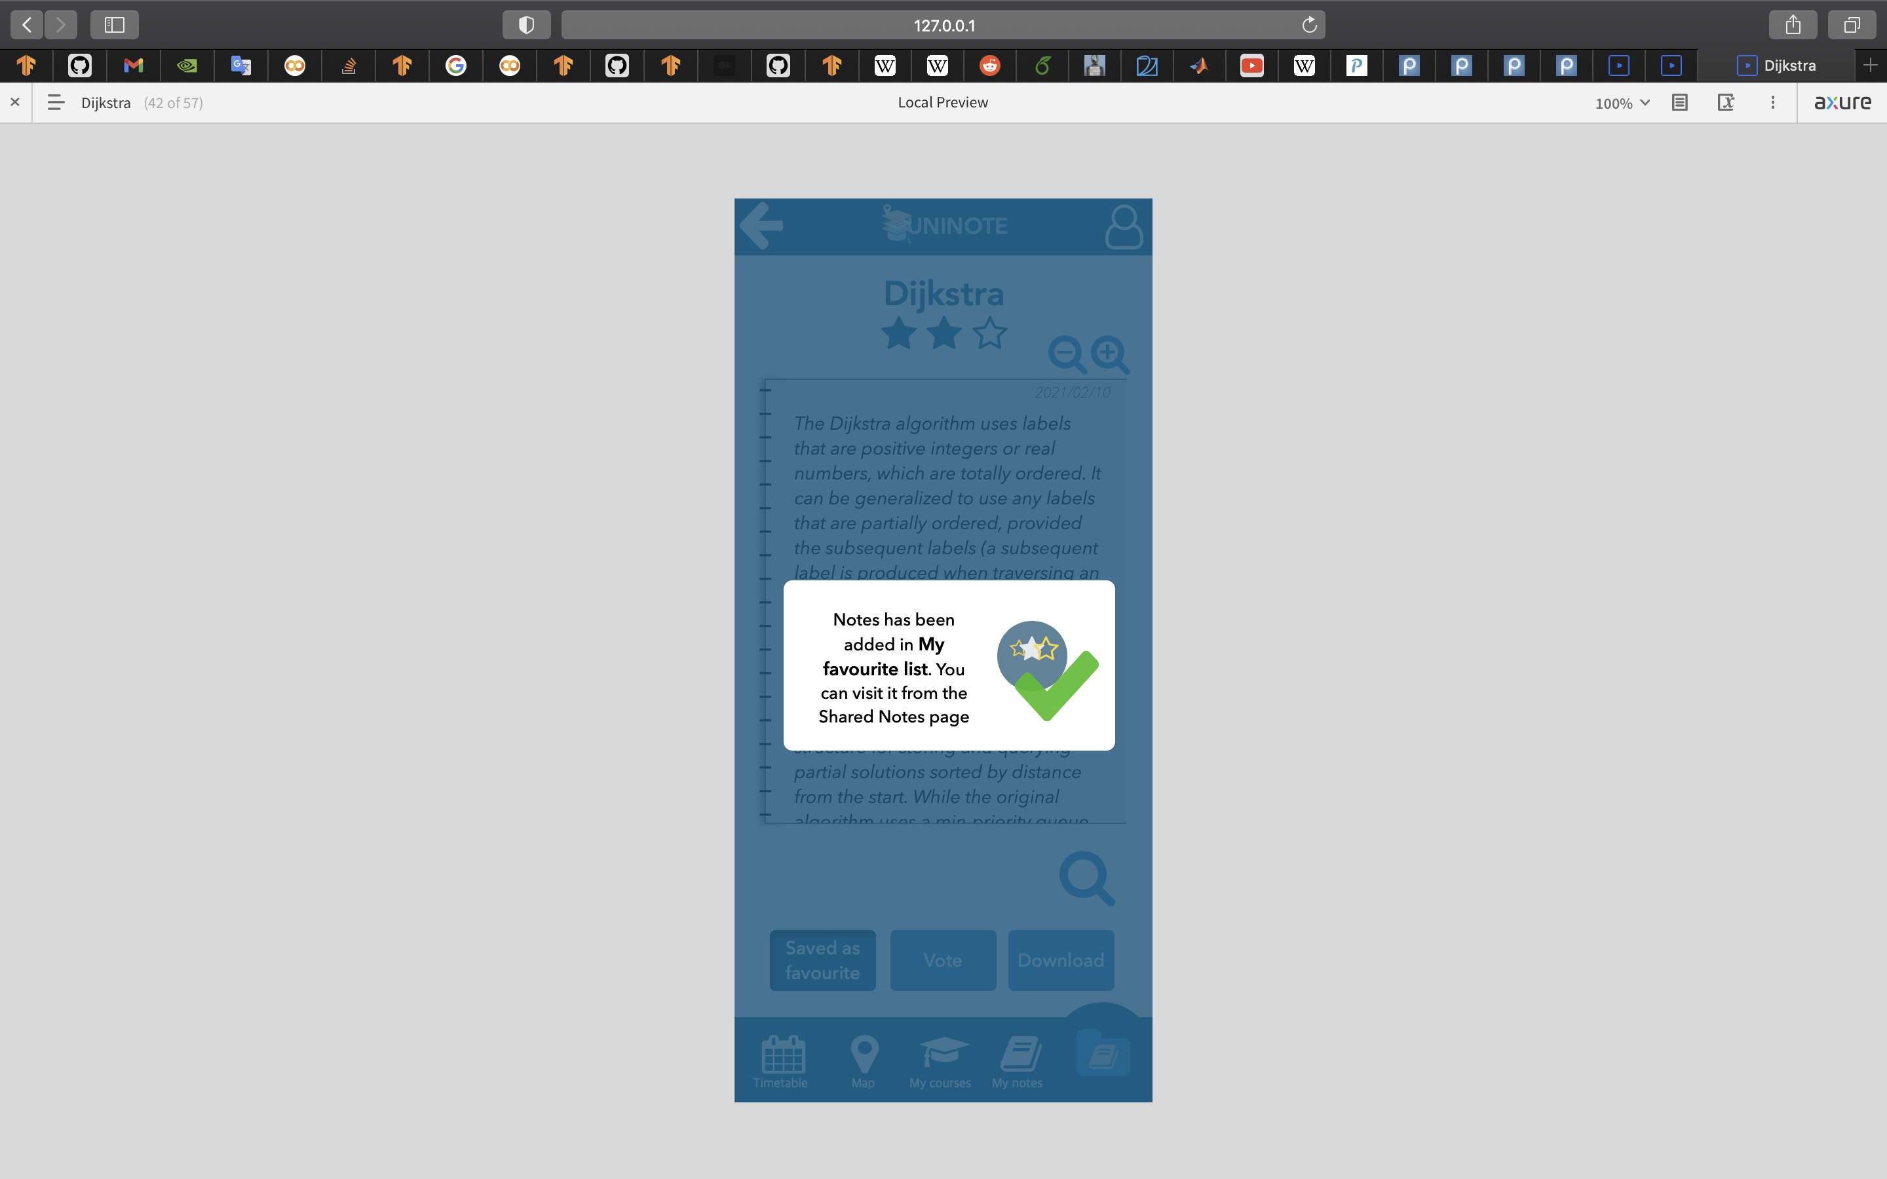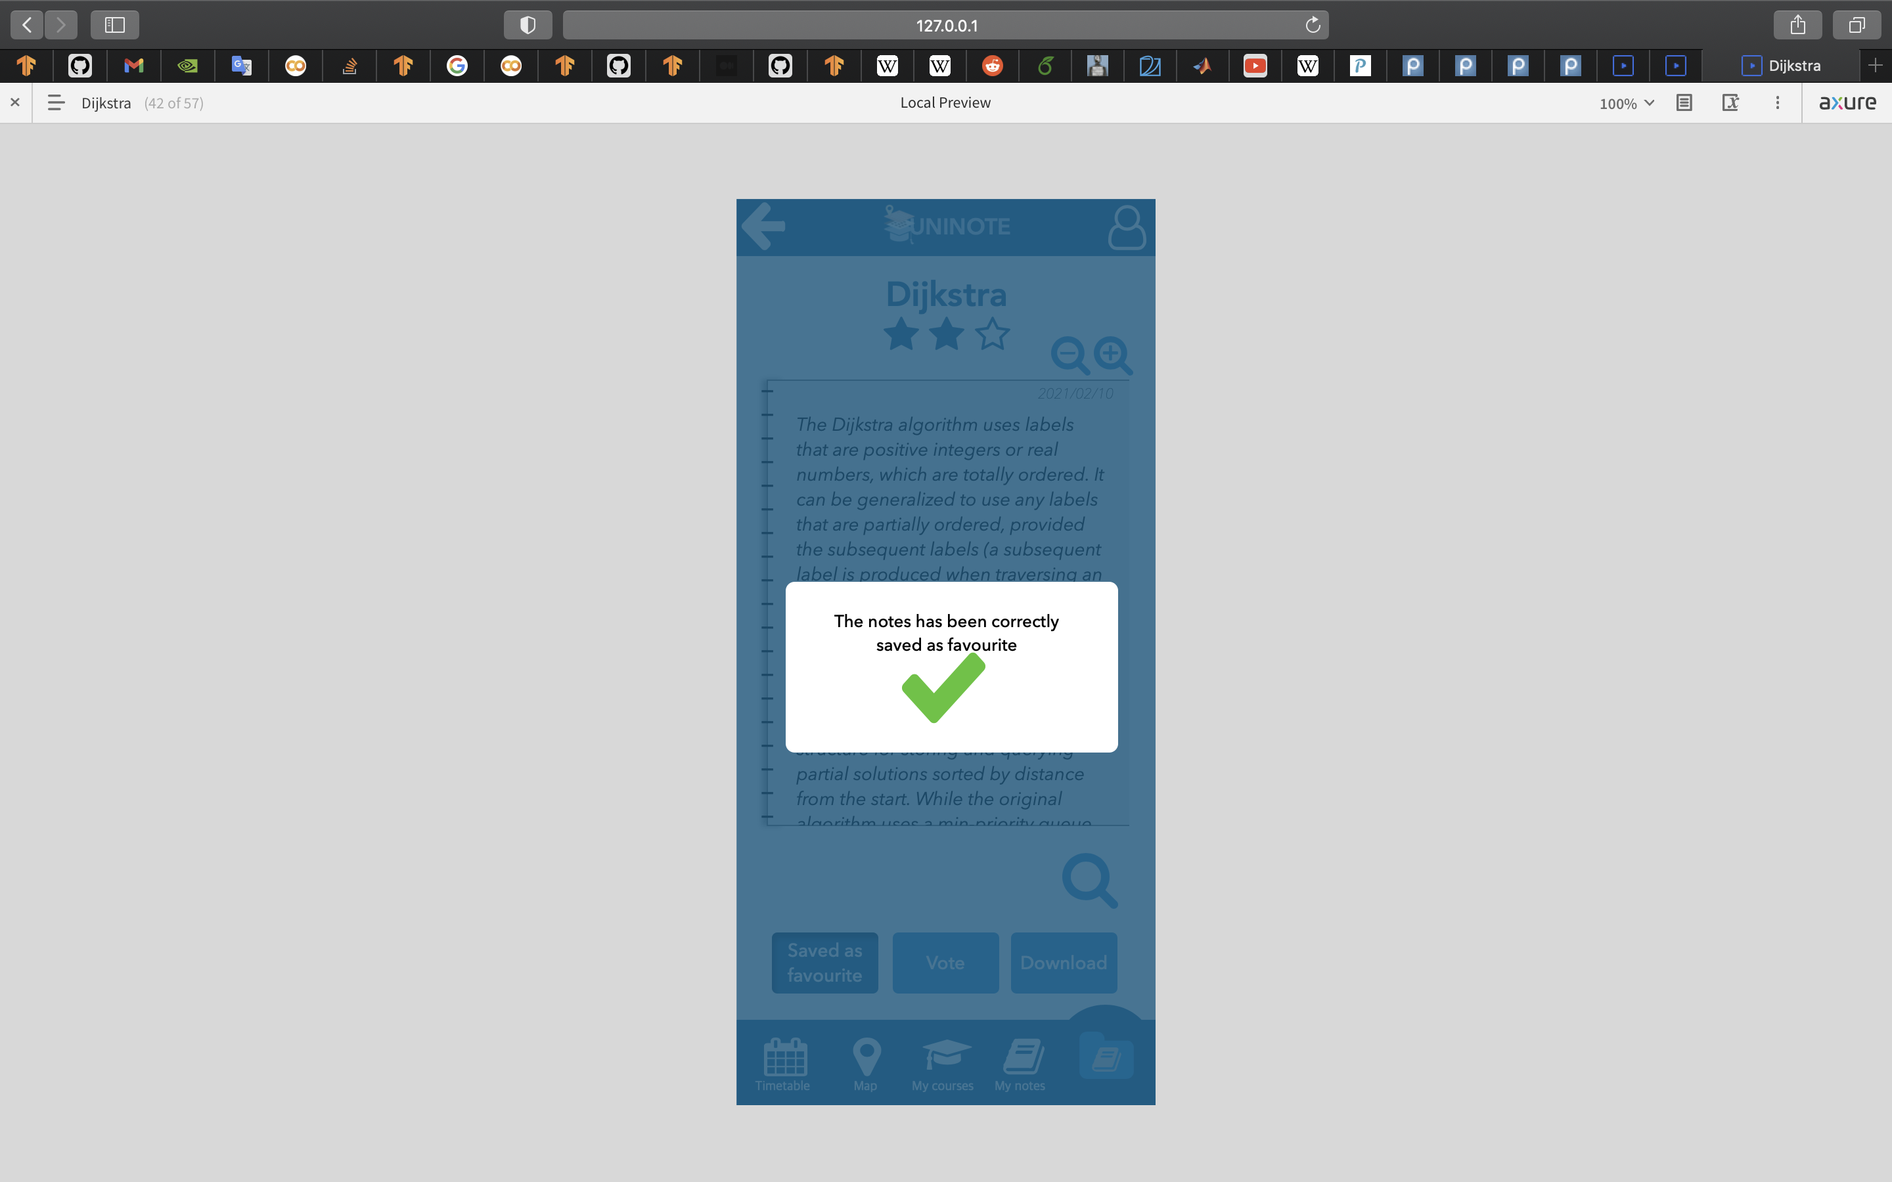

* Providing user a more comfortable lesson’s schedule: the user will see the entire timetable by scrolling left and right the page. We made this change after the Think Aloud evaluation. During the evaluation, users had difficulties in reading the name of the courses (since they were in only one page). Even if the priority of this incident was the lowest one, we solved this problem by adding the scroll option.

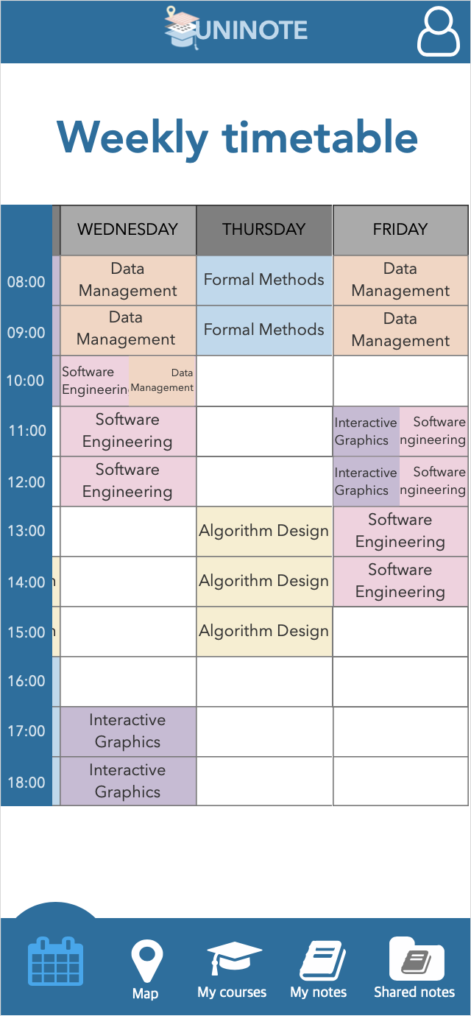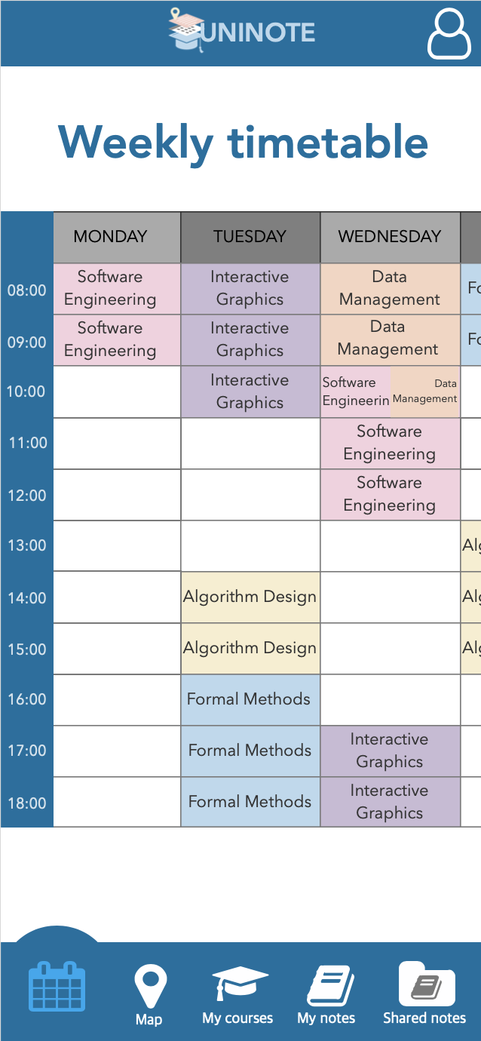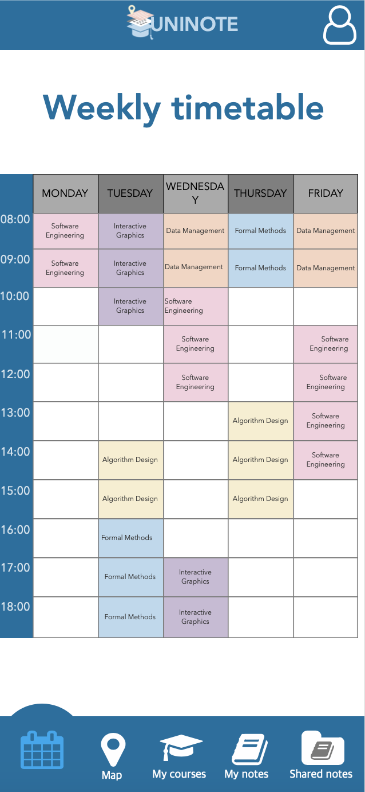

**Final system**

The fourth prototype is the last one. So, let’s see the final system:

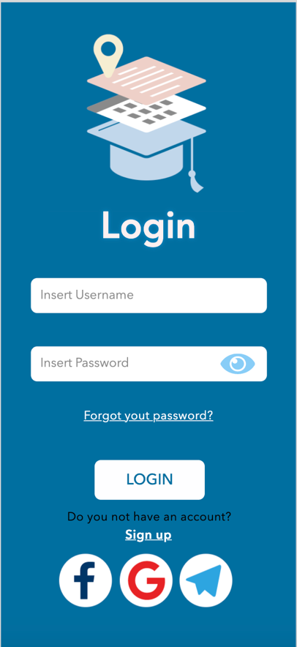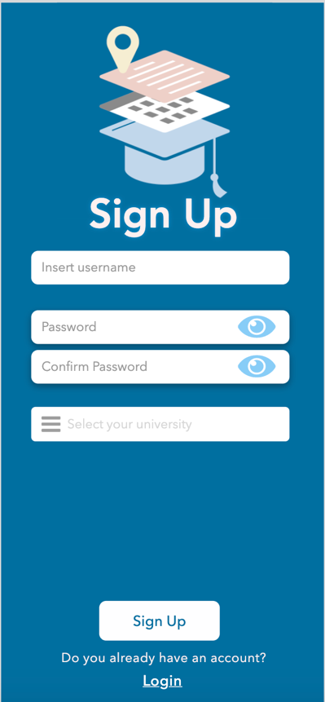

*Figure 42. Login*

*Figure 43. Sign Up*

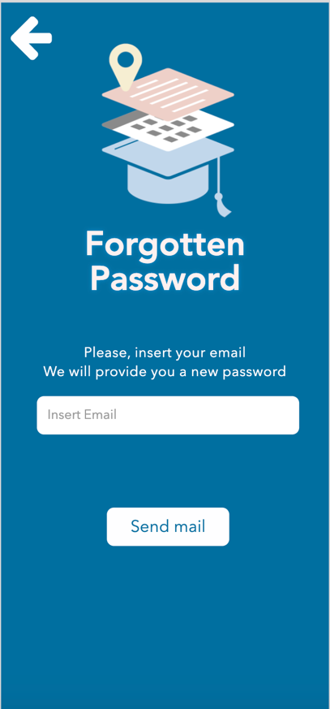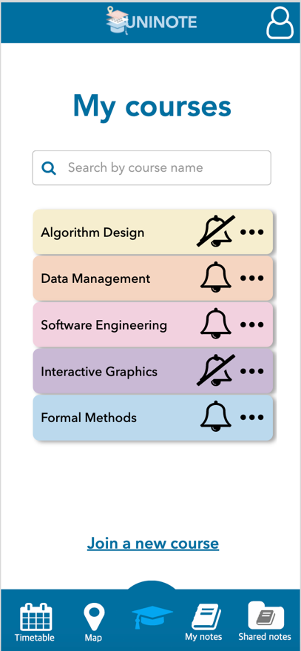

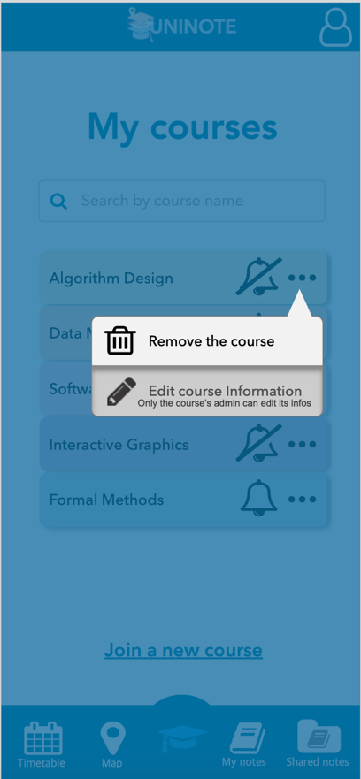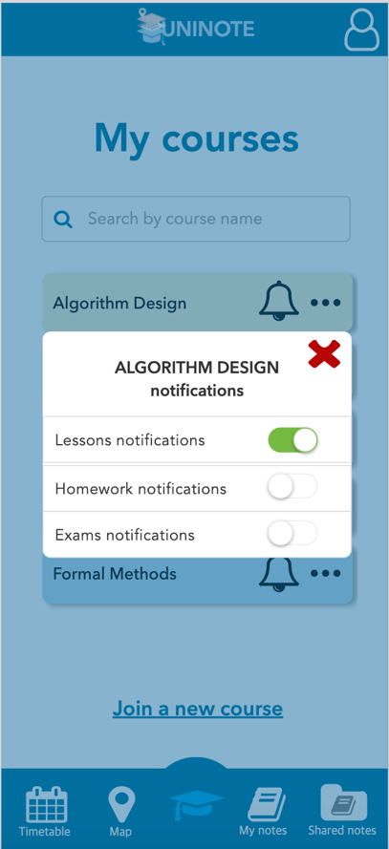

*Figure 47. Options for editing and removing a course*

*Figure 44. Forgotten Password*

*Figure 46. Notififcation management*

*Figure 45. My Courses*

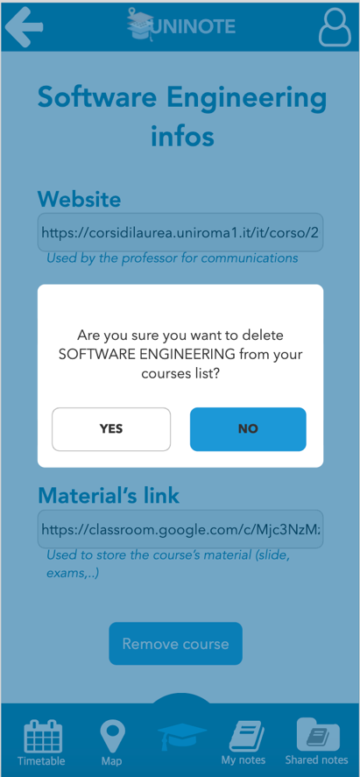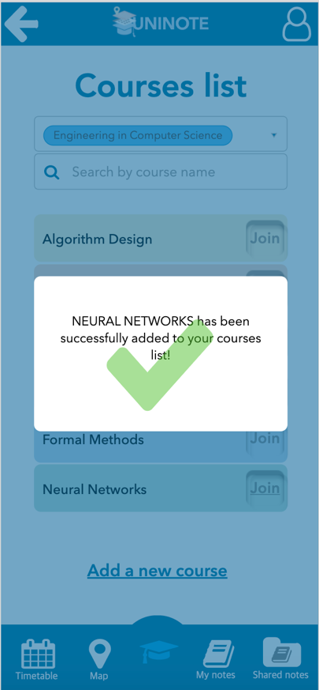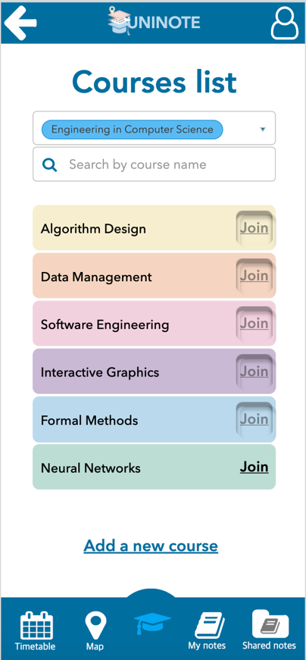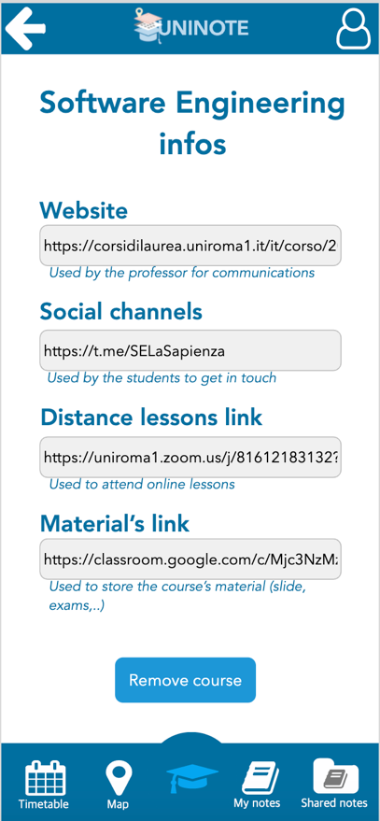

*Figure 51. Confirmation message that a*

*course has been joined*

*Figure 50. All courses list*

*Figure 49. Confirmation message for deleting a course*

*Figure 48. Course details*

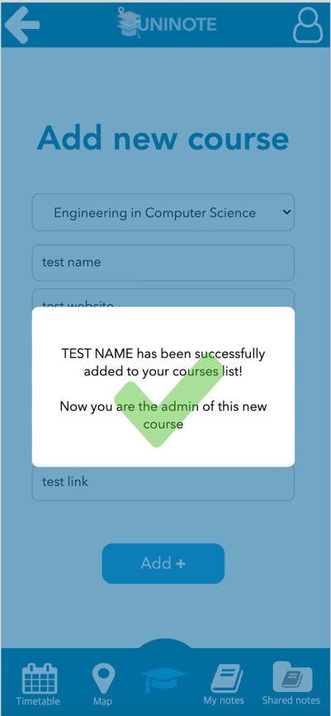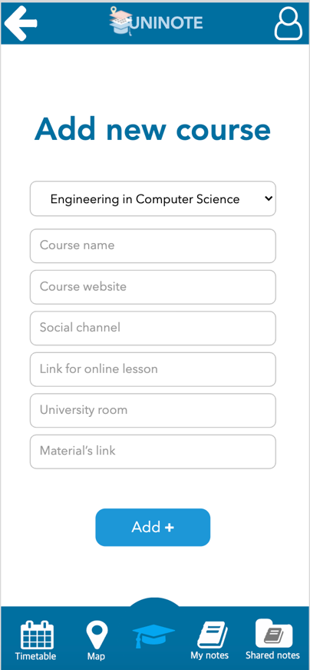

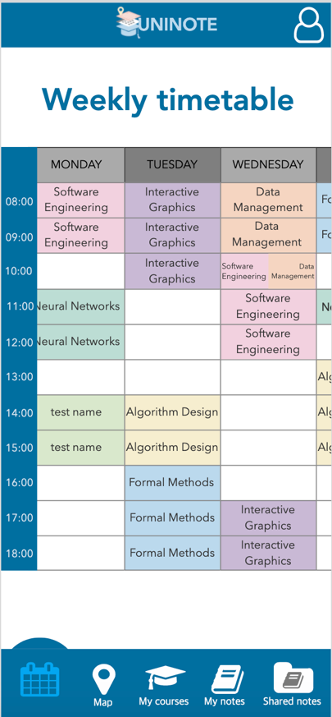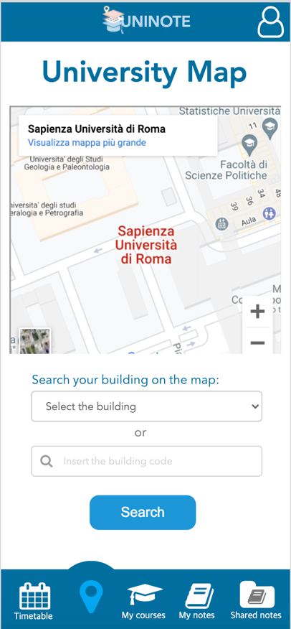

*Figure 55. Timetable*

*Figure 54. University map*

*Figure 53. Confirmation message that a new course has*

*been added to the courses list*

*Figure 52. Add new course form*

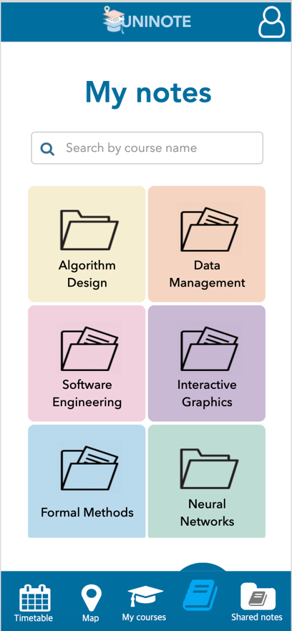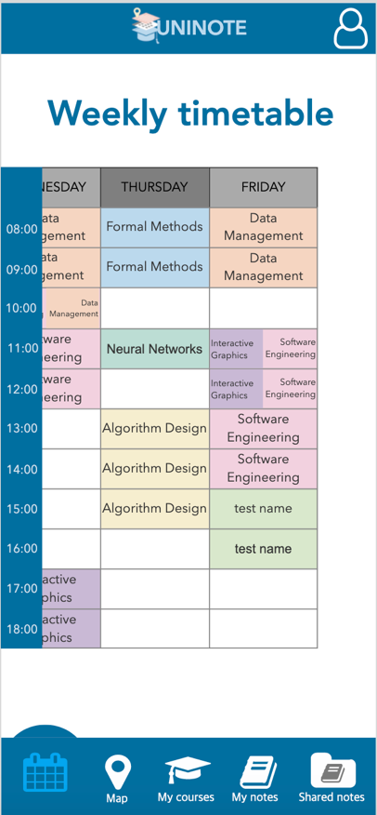

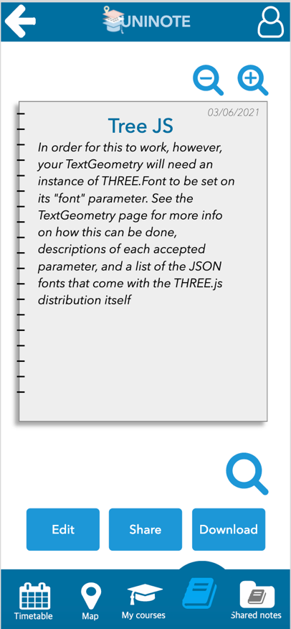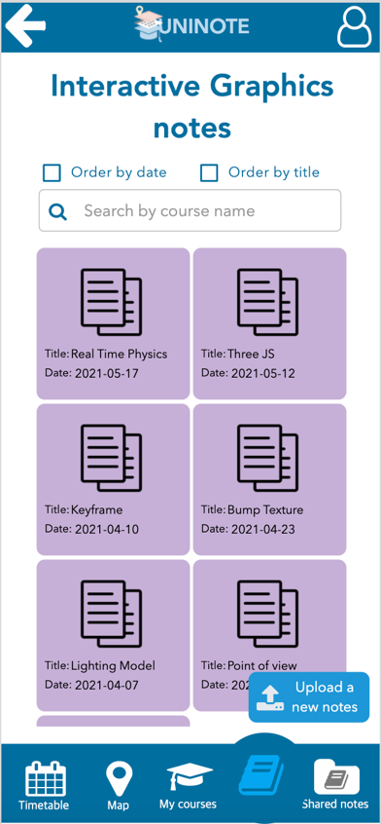

*Figure 59. Page of a specific private note*

*Figure 58. Private notes belonging to a specific course*

*Figure 57. My Notes*

*Figure 56. Timetable*

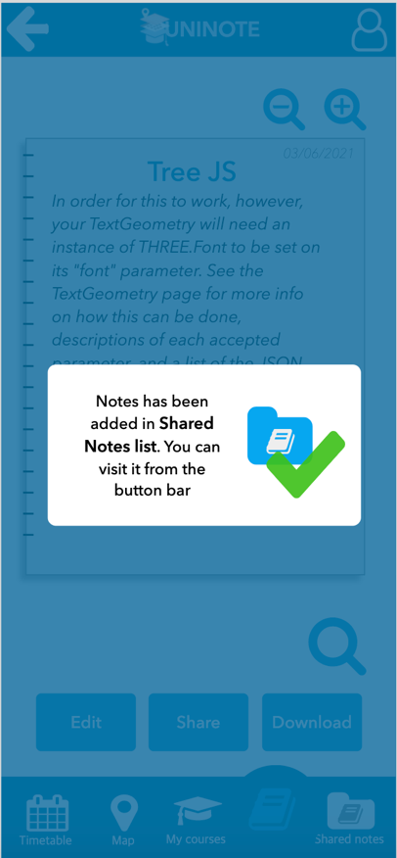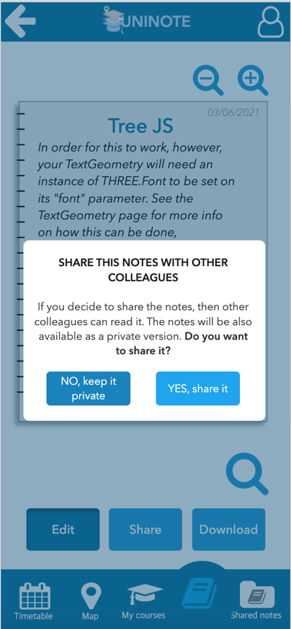

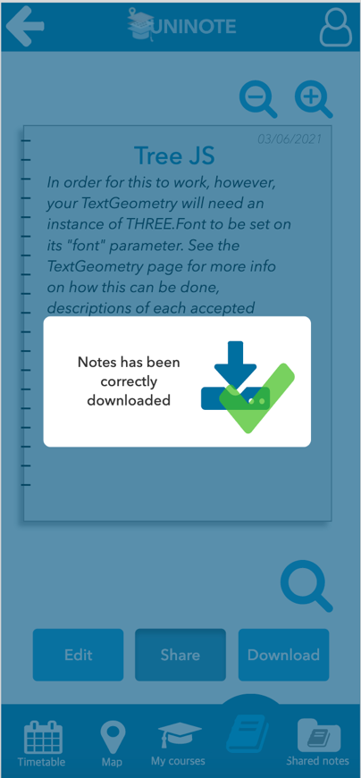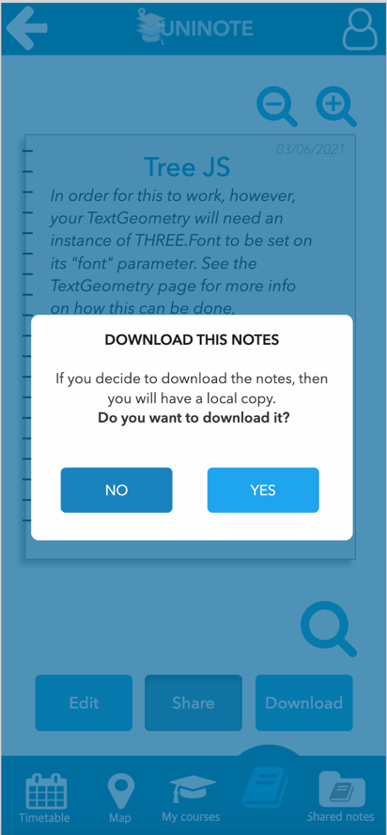

*Figure 63. Confirmation message that a specific*

*note has been downloaded*

*Figure 62. Download option*

*Figure 61. Confirmation message that a specific*

*note has been shared*

*Figure 60. Share note option*

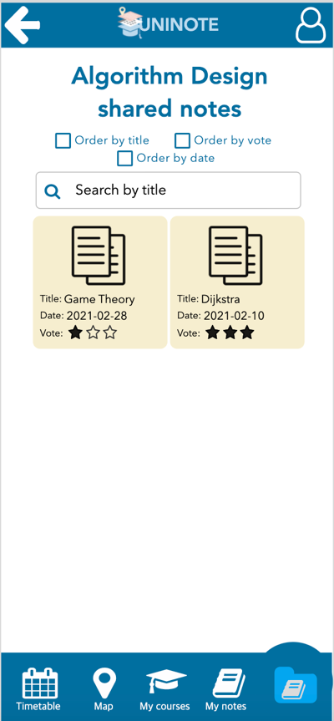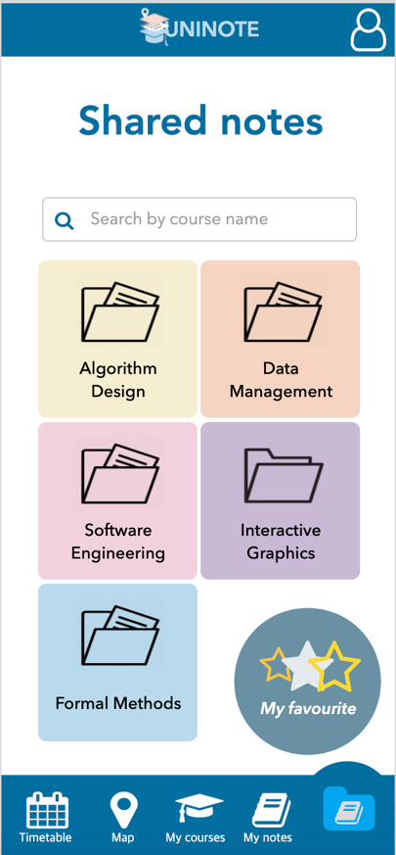

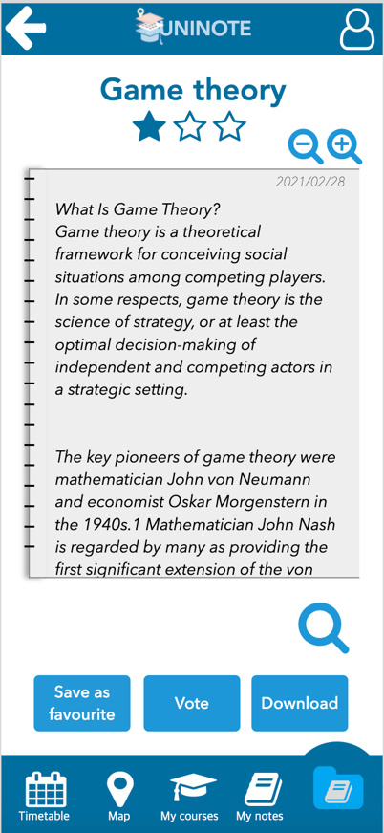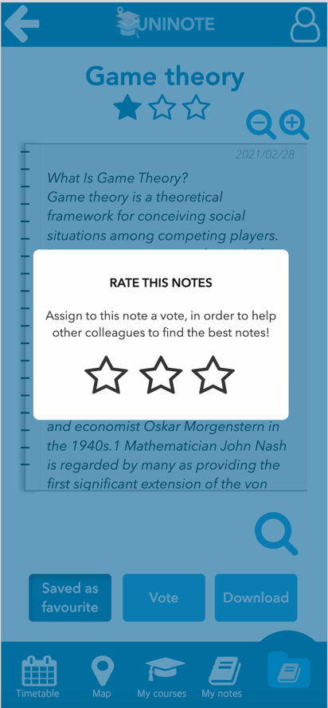

*Figure 66. Page of a specific shared note*

*Figure 67. Ranking note option*

*Figure 65. Shared notes belonging to a specific course*

*Figure 64. Shared notes*

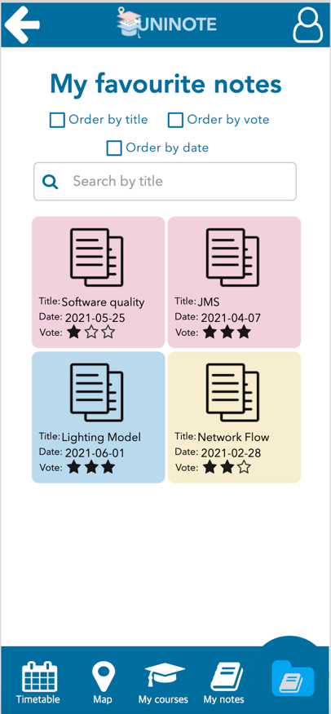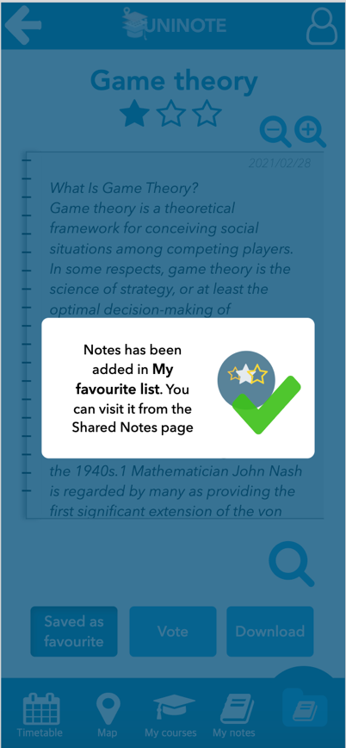

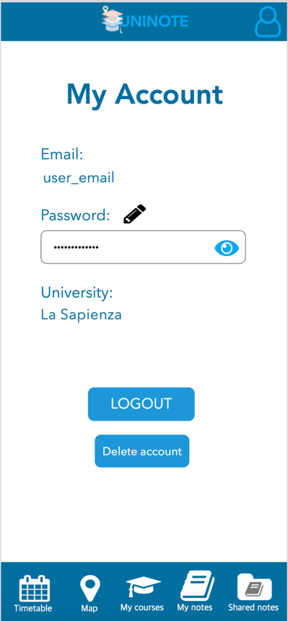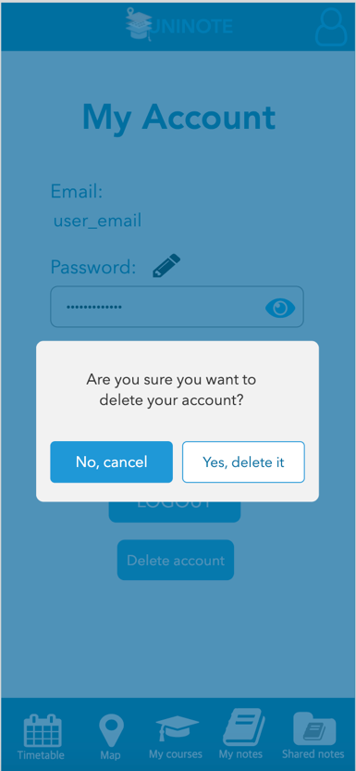

*Figure 70. My Account*

*Figure 71. Deleting account*

*Figure 69. My Favourite Notes*

*Figure 68. Confirmation message that a specific shared note has been added to the favourite list*

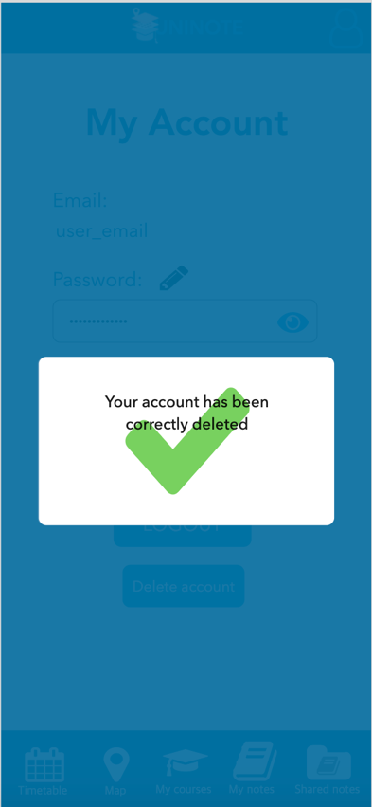

*Figure 72. Confirmation message that the account has been correctly deleted*

1. **Conclusion**

Thanks to the Human-Computer Interaction course, we improved our skills in developing mobile applications and interfaces. We put the focus on the usability of our app in order the make the use of it easier for the users. To achieve this mission, we collected requirements, feedback and we had our system evaluated by users and by the expert Valeria Mirabella.

* 1. **Future works**

First, we would like to develop the desktop version of our application. Then, we would like to make the system usable worldwide and so we want to make the app usable by many universities in order to help the organization of an increasing number of students! ☺

1. **References**

* Course’s material by Catarci T. and Mirabella V.;
* Balsamiq mockups;
* https://www.excel.com/examples/anova.html;
* Dix A., Finlay J., Abowd G. D., Beale R., *Human-Computer Interaction*. Third edition, Pearson, 2004.